2/29/2016

Assignment 2

Unit 2

Simon Light

UTC Reading

Contents

P5 – Set up standalone computer system 2

Introduction 2

Health and safety 2

CPU 3

RAM 7

Software 9

P6 – Configure a computer to a user’s need 11

Power saving options 11

Screen resolution 14

Desktop theme 15

Font size 18

Default language 20

P7 – Test a configured computer 22

P8 – Routine maintenance 22

Restocking printer 22

Paper 22

Ink 22

Defragging disk 22

M3 – Evaluate performance of a computer 23

D2 – Explain and justify improvements to a computer 23

Copyright Law 23

Limitations imposed by copyright 23

Prevention of software piracy 23

Legal implication of using and editing images 23

Where to find free images 23

Appendix 24

# P5 – Set up standalone computer system

## Introduction

I was tasked to set up a standalone computer. I was given a computer that was not functioning and asked to diagnose and fix any issues found.

## Health and safety



We started by finding a place in the room that was clear and away from any electronics. We then placed an anti-static mat on the table and connected ourselves to the mat via the band shown above.

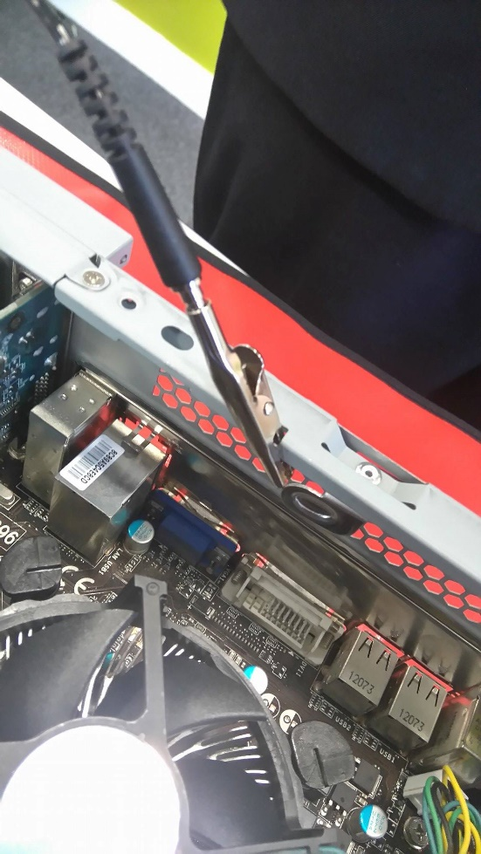

We then went and got the computer we were required to work on and placed it onto the mat. After removing the side panel we attached the antistatic mat to the computer via the crocodile clip shown above. Completing the circuit between the computer, the mat and myself meant that no electricity could be passed between myself and the computer. This removes the risk of damaging sensitive components.



I then made sure that all loose pieces of clothing were removed. This included lanyards, rolling sleeves up, tie etc. Doing this mean that nothing would touch computer hardware other than my hands. This again would prevent against damaging sensitive components. It would also prevent any piece of clothing being caught in the fan, possible damaging it or you.

## CPU

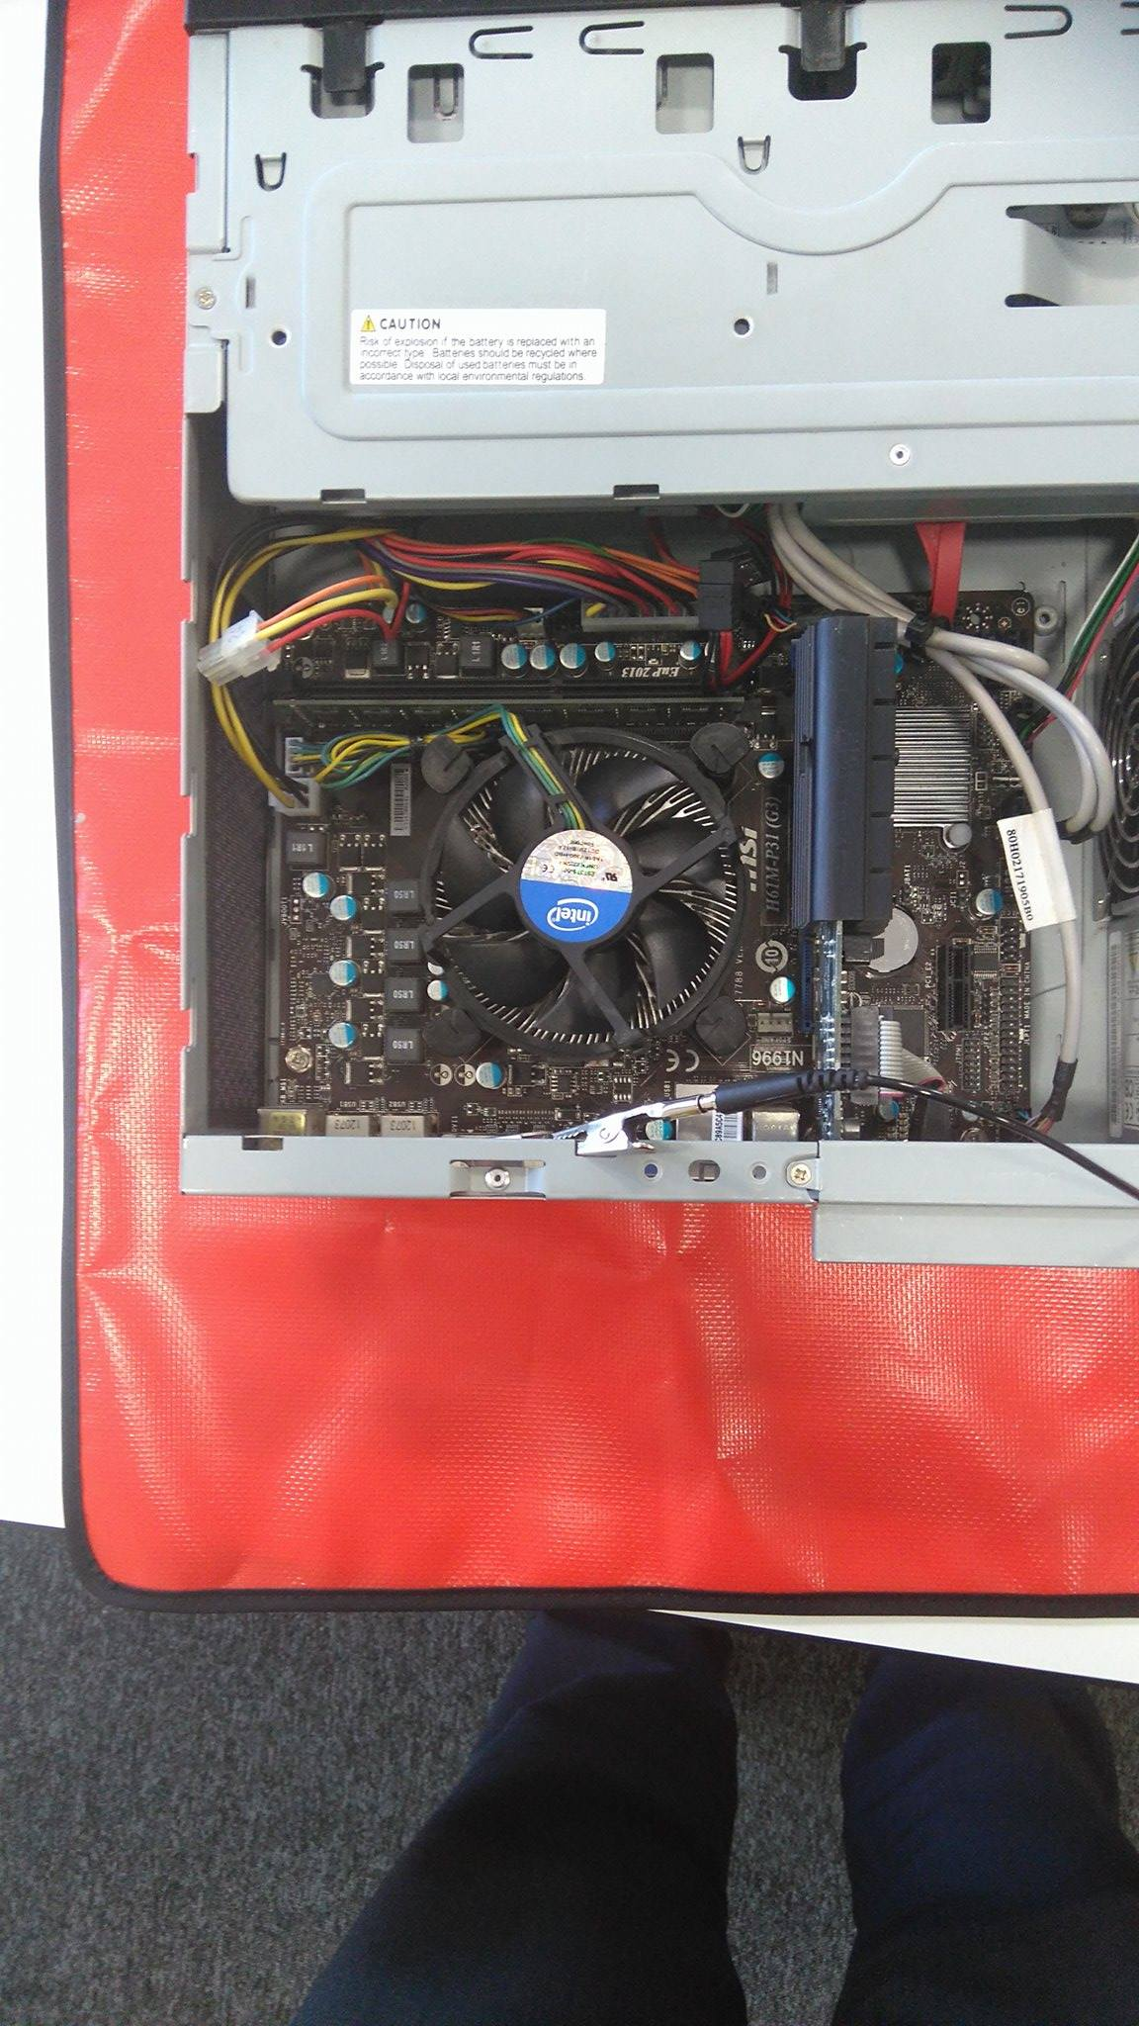

On opening the computer this is what we found. We noticed that one of the pins on the CPU heat sink was not in properly. Due to this we decided to remove it entirely and reinstall it.

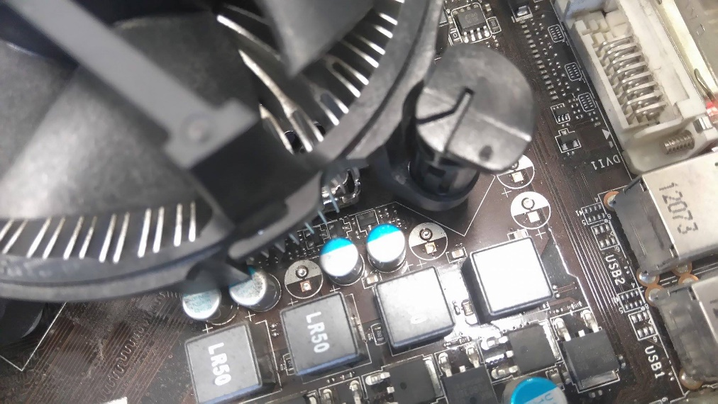

This is the pin that was loose.

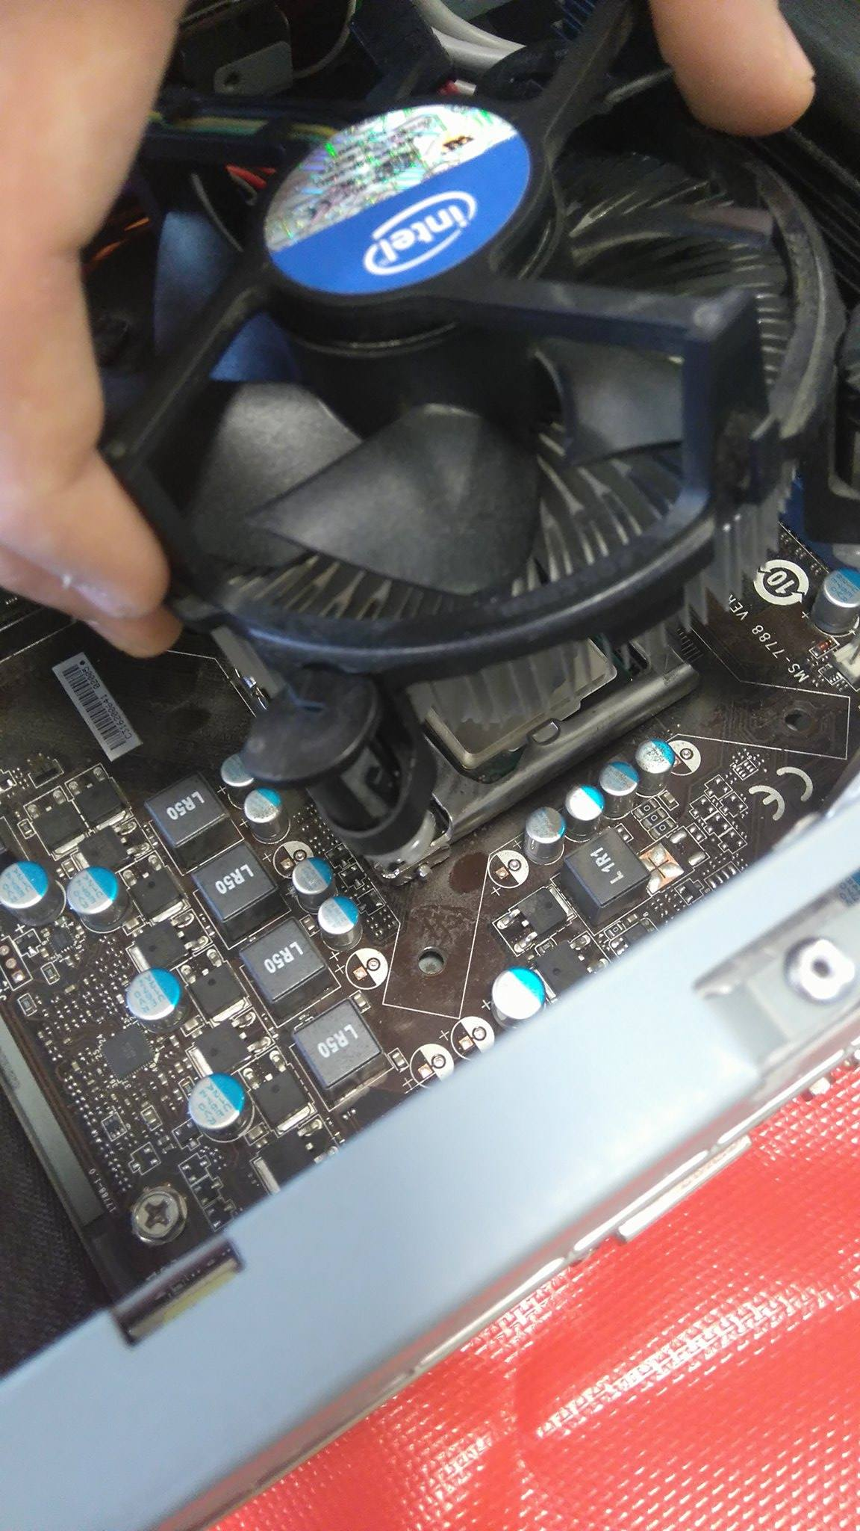

After loosening each of the pins individually, by twisting and then pulling, I then removed the heat sink.

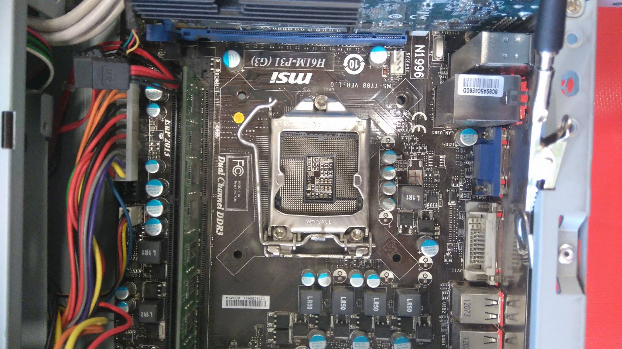

After removing the heat sink we discovered that there was no CPU on the motherboard. This was discovered as one of the issues with the computer.

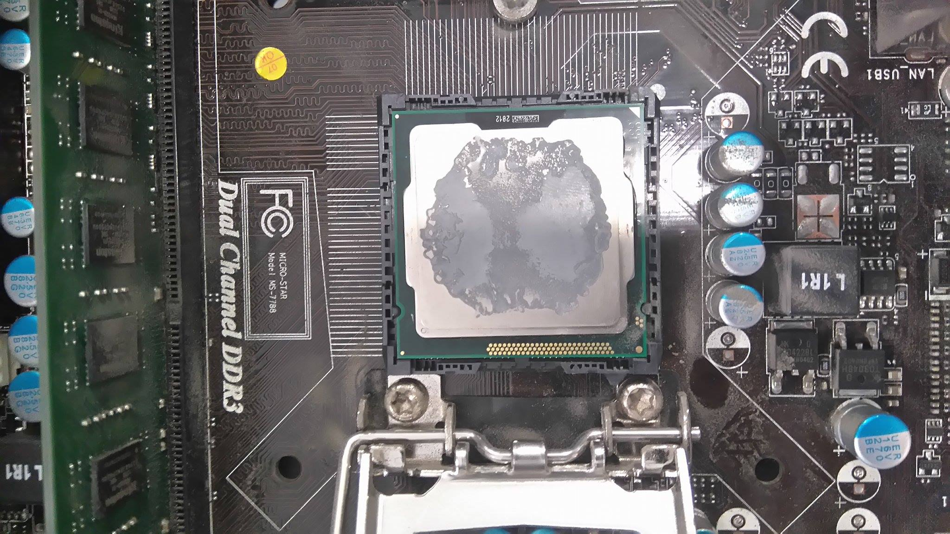

To rectify this error we opened the socket by lifting the retention arm. We then found a CPU that matched the socket type that we had on the motherboard. We then placed the chip in the socket making sure that we lined up the notches with the holes on the socket and CPU.

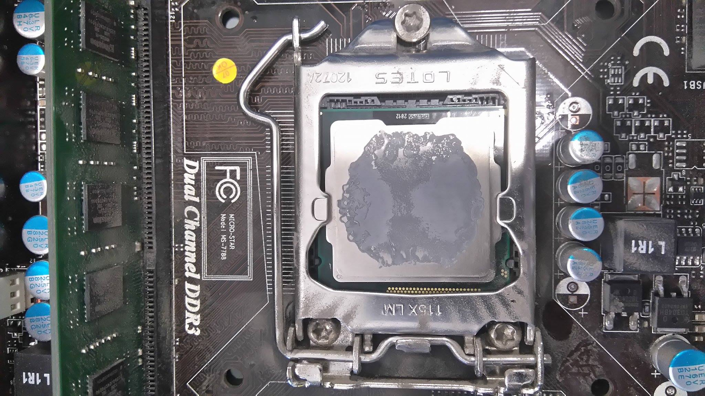

I then lowered the retention arm and slid it into its holder pin. This ensured a strong connection between the CPU and the Motherboard.

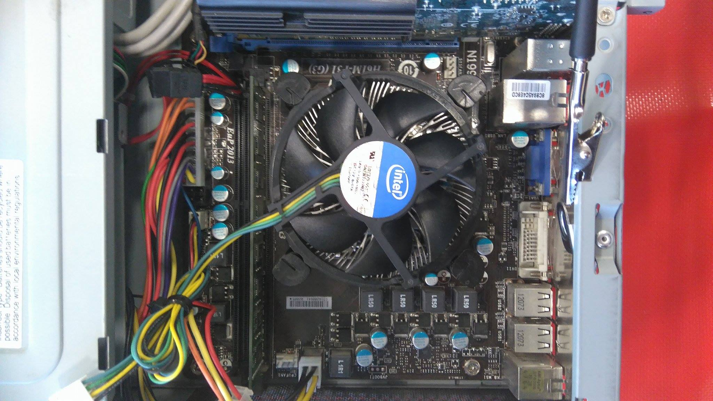

We then placed the heat sink back on the board and tightened the pins.

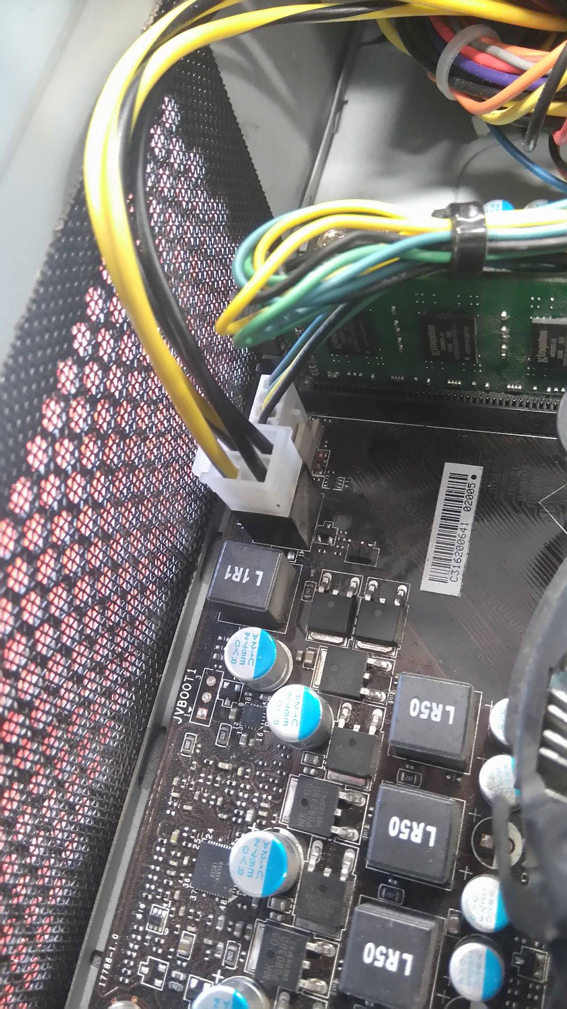

I then plugged in the fan header for the heat sink so that the fan would spin when needed.

## RAM

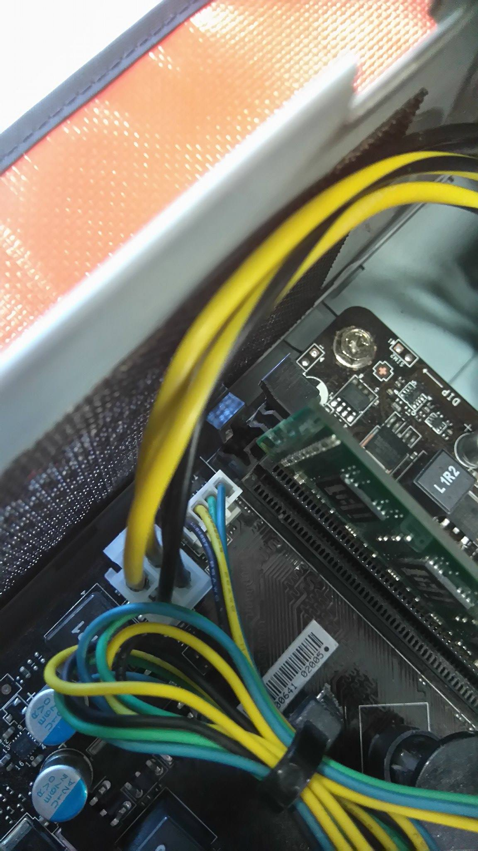

I noticed that the RAM was not installed correctly. Due to this I decided to again entirely remove it and then re-install it.

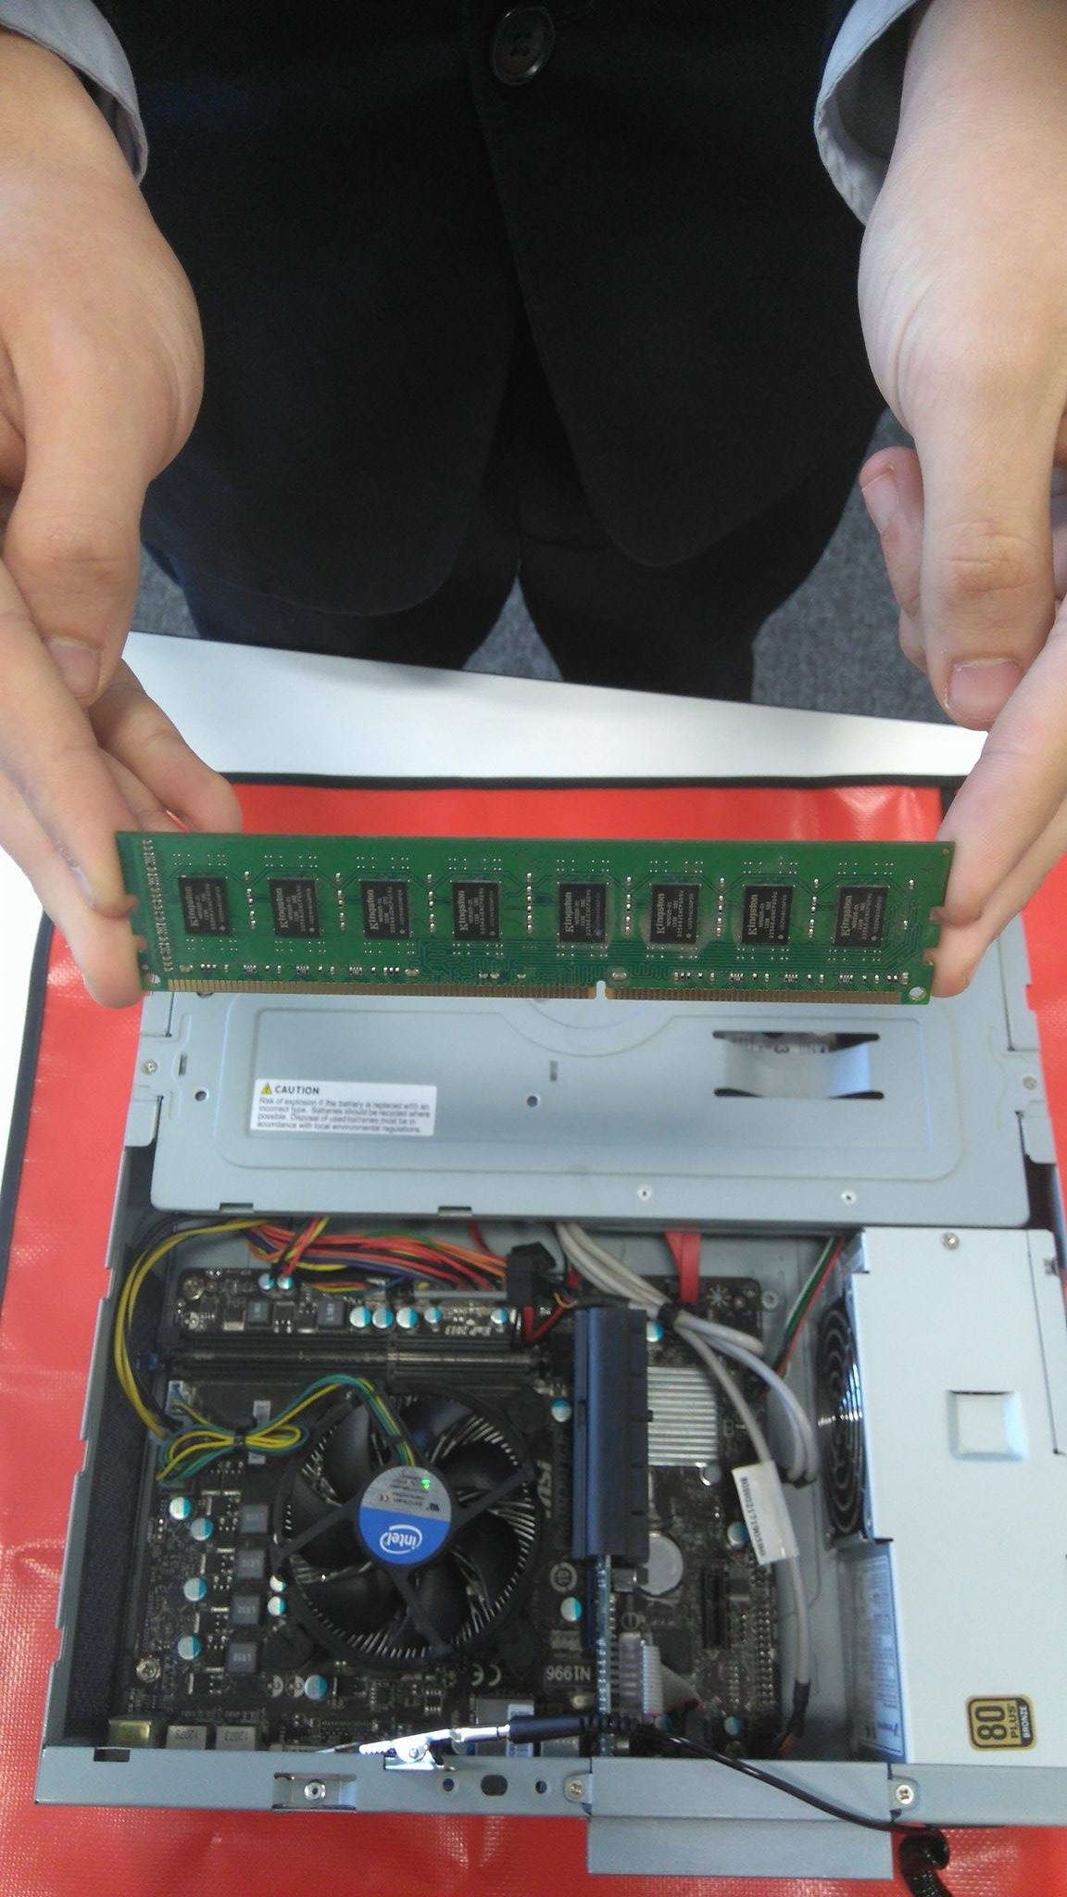

We removed it by pushing down the pins either side of the stick and lifting the RAM out. Above is an example of how you should hold the stick once removed. It avoids touching any connections, possibly damaging the stick.

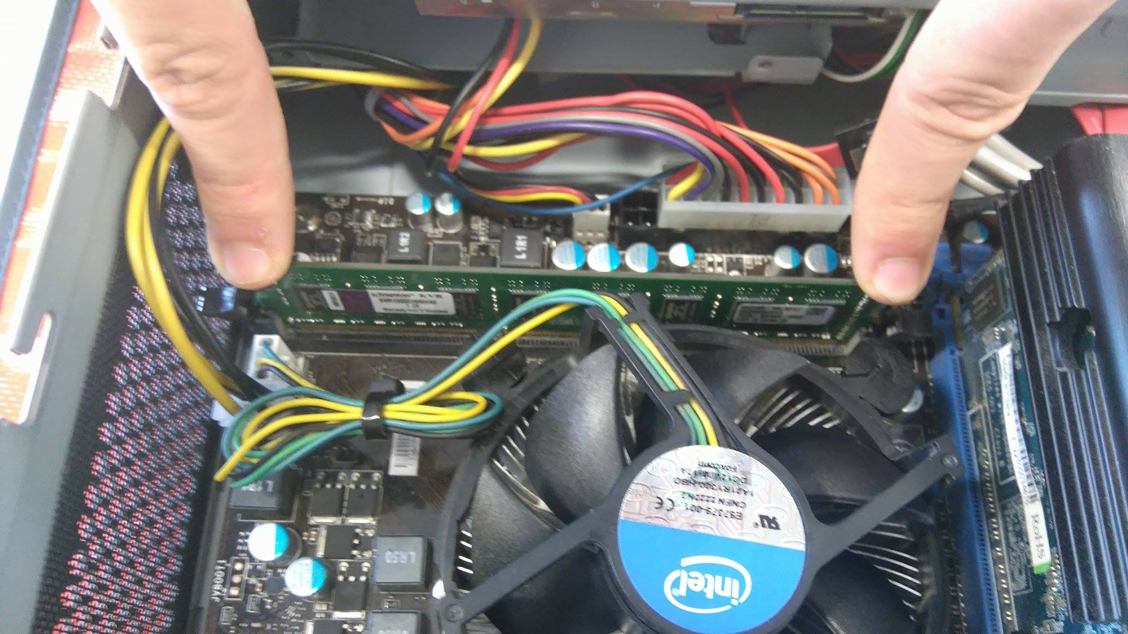

I then placed the stick in the socket and pushed evenly on both sides. It is important to line up the stick with the long side and short side of the socket. When you hear a click from both pins It is correctly installed.

## Software

I decided that one piece of softwar that the company would need is Microsoft Office. This would be used for general word processing, tables (in Excel) and more advanced things like databases (in access).

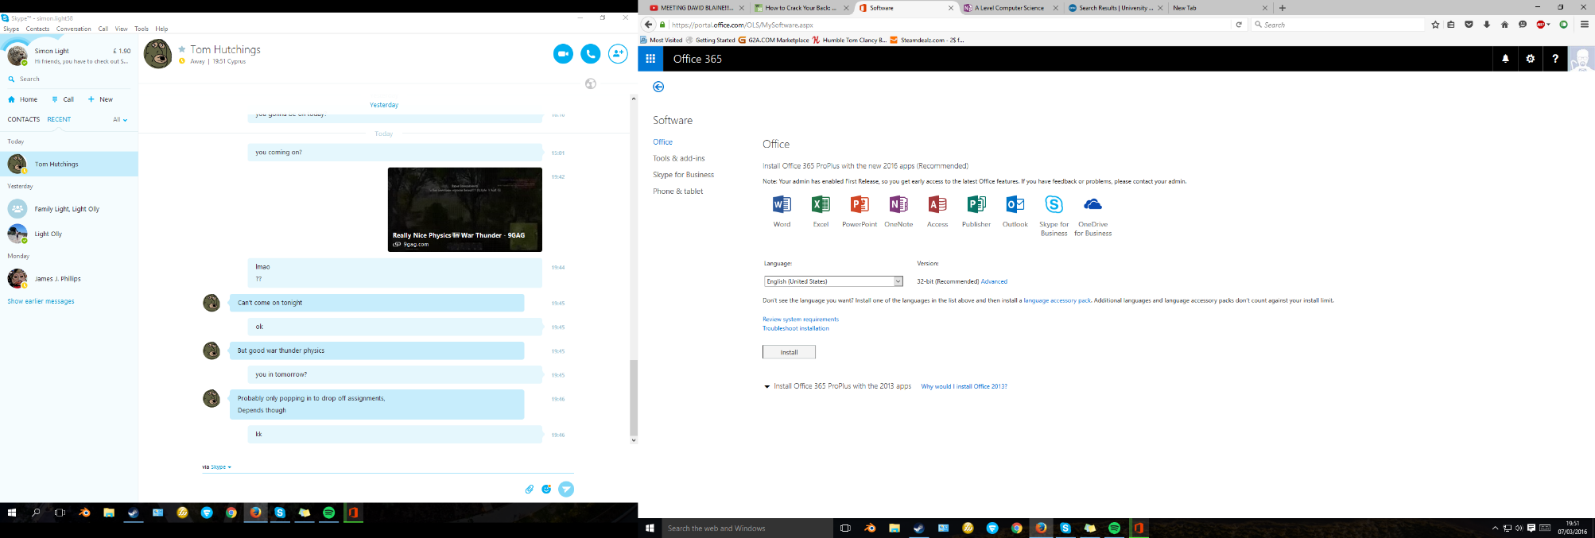

I next went on to the internet and found a place to download the latest version of Office which is 2016. I then selected my language to install in and pressed install.

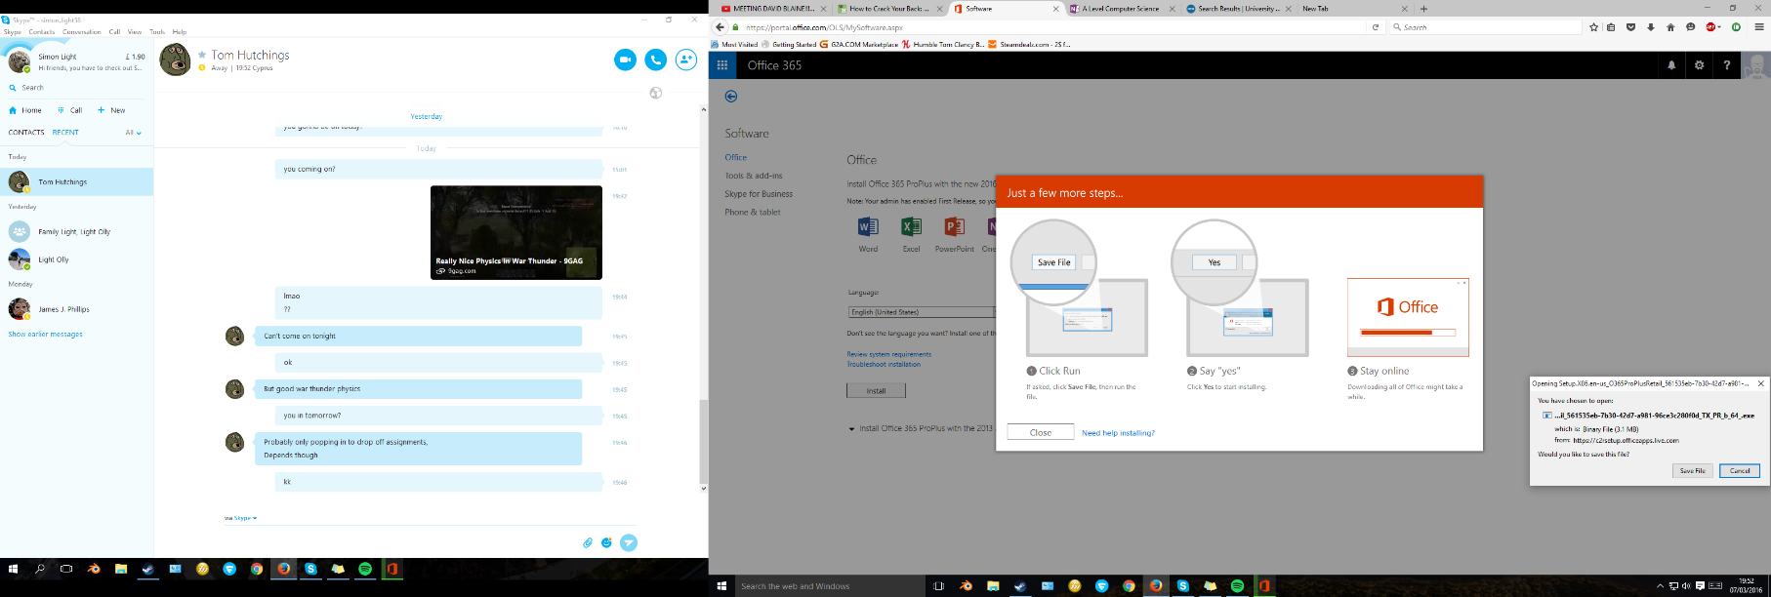

I was then prompted with a window asking me whether I wanted to save the file, I did. I then followed the instructions on screen to run the file. This consisted of pressing yes when asked.

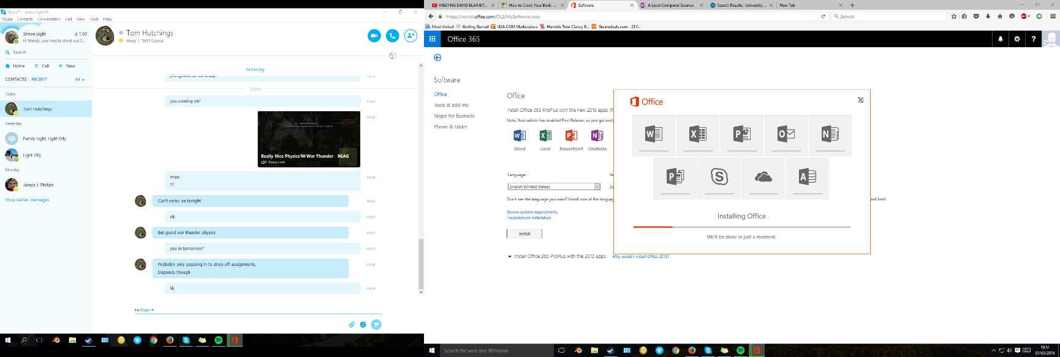

I was then given an Office installation screen that began to install the software in my default location. This means that it will be available through the start menu and the programs section in controll panel. The window showed me how far throught the installation it was aand what it was doing at each point.

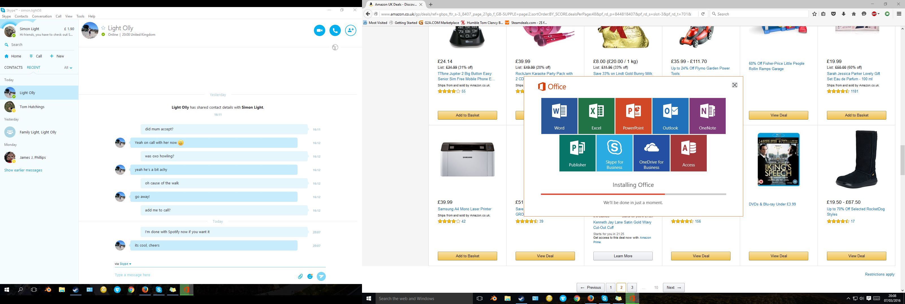

One by one after the programs had installed they became coloured rather that black and white. You could then click on these to run the program and confirm it was working ok. After all of the programs were installed it carried on doing some setting up but all of the applications could be used.

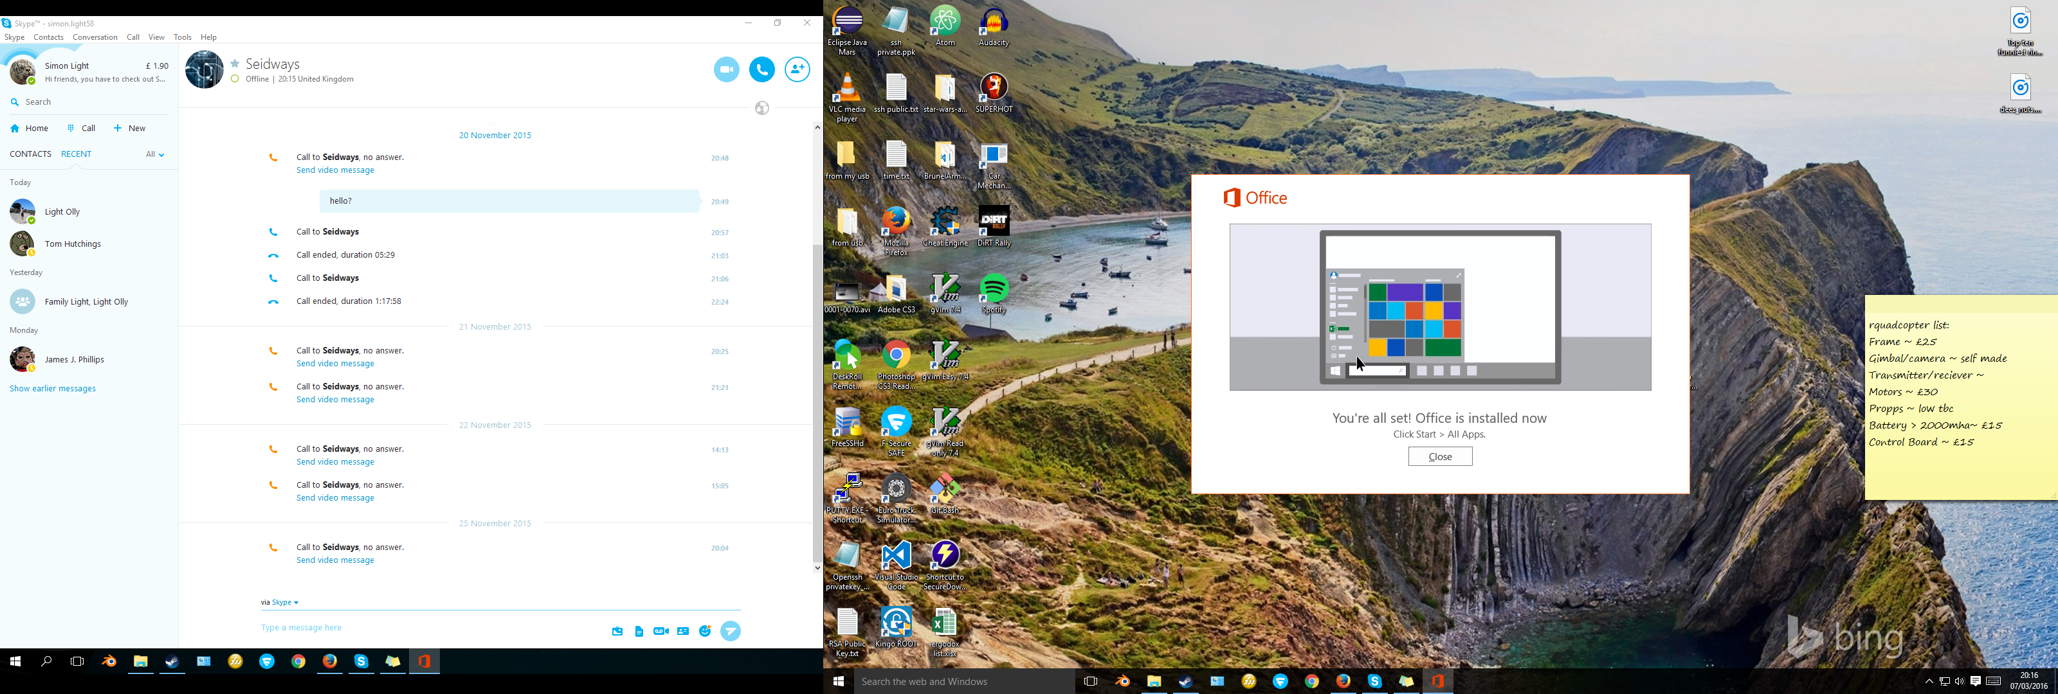

After the installation had completely finished I was shown this window. It explained that the applications that I installed could be found in the start menu.

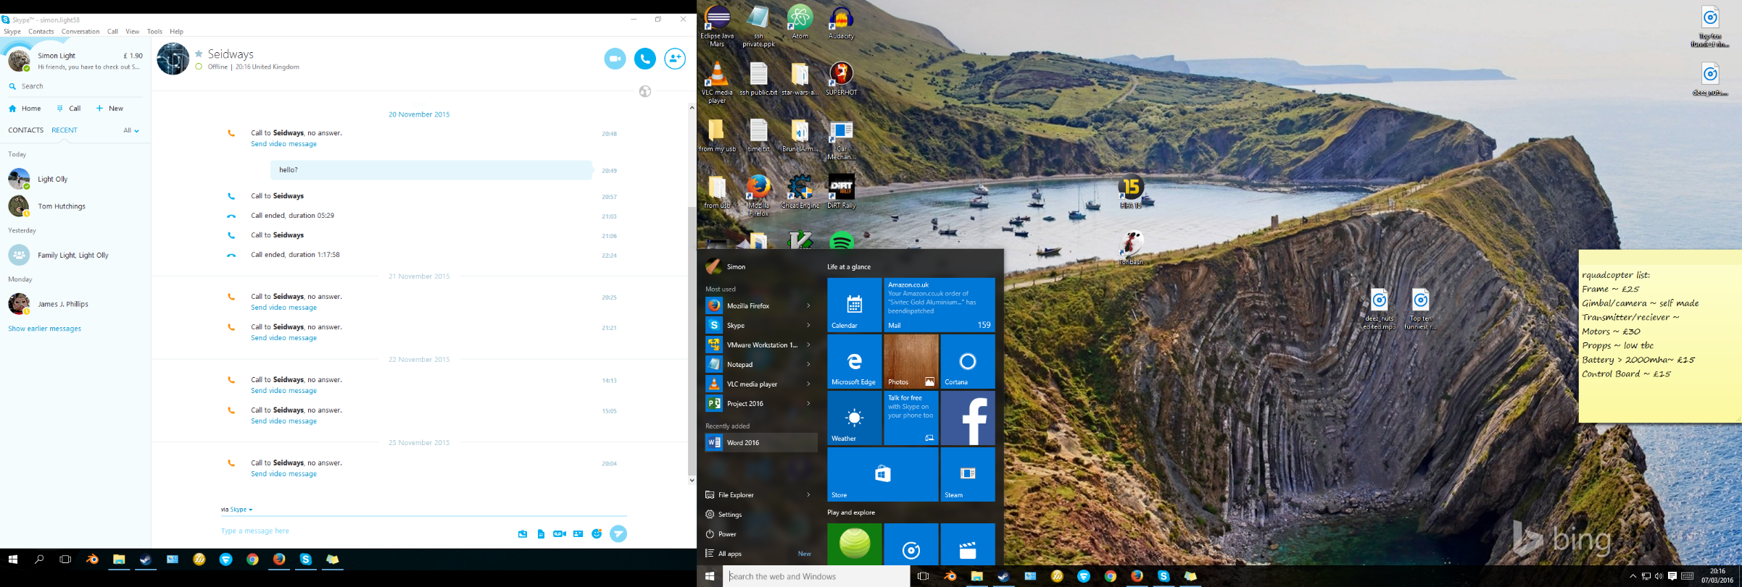

I then pressed clos on that window and proceeded to check. As you can see in the image above the applications were there and they all worked fine.

# P6 – Configure a computer to a user’s need

In this section I will configure a computer to a user’s needs.

## Power saving options

Here I am going to set up the computer to never turn off the display when it is charging. This will be good for running slideshows to customers of the TelXGroup.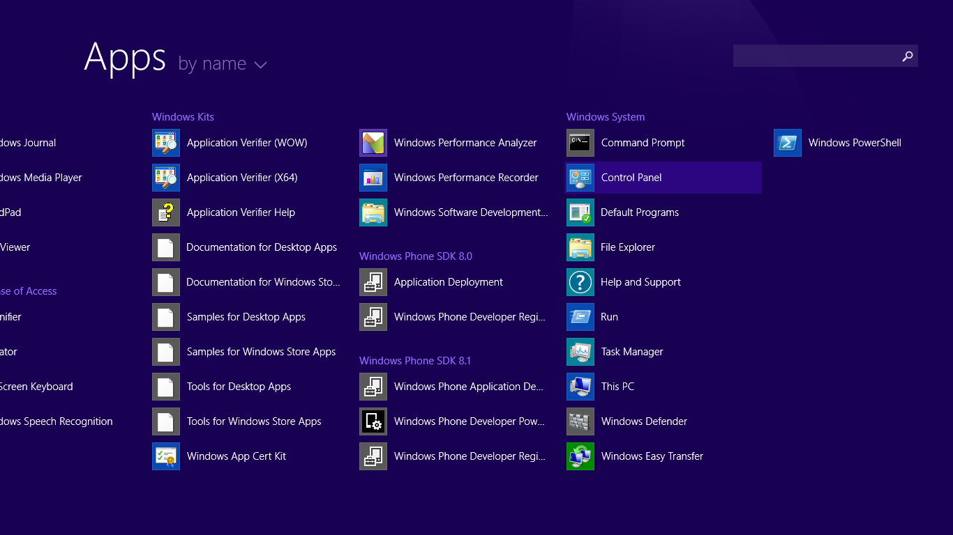

I firstly opened control panel by going through Start, down arrow then Control Panel.

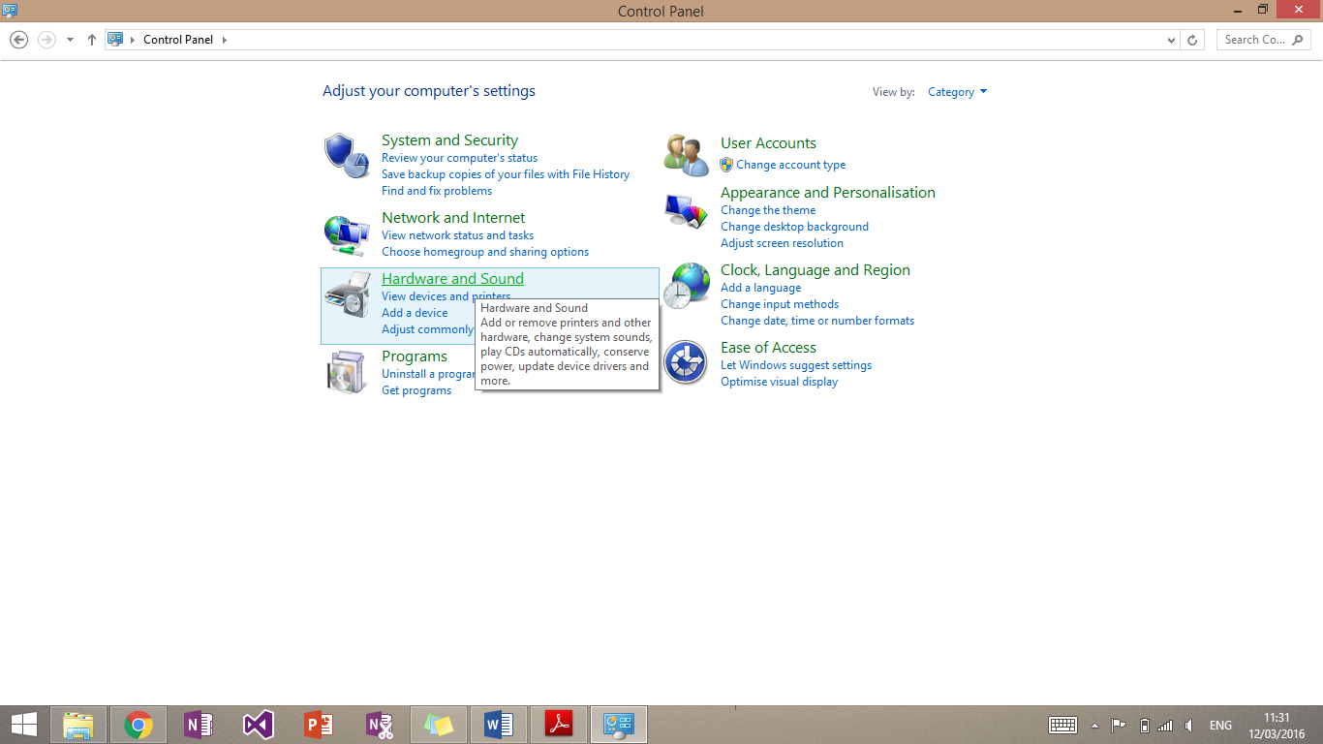

I was then presented with the main control panel page. I then clicked on ‘Hardware and Sound’.

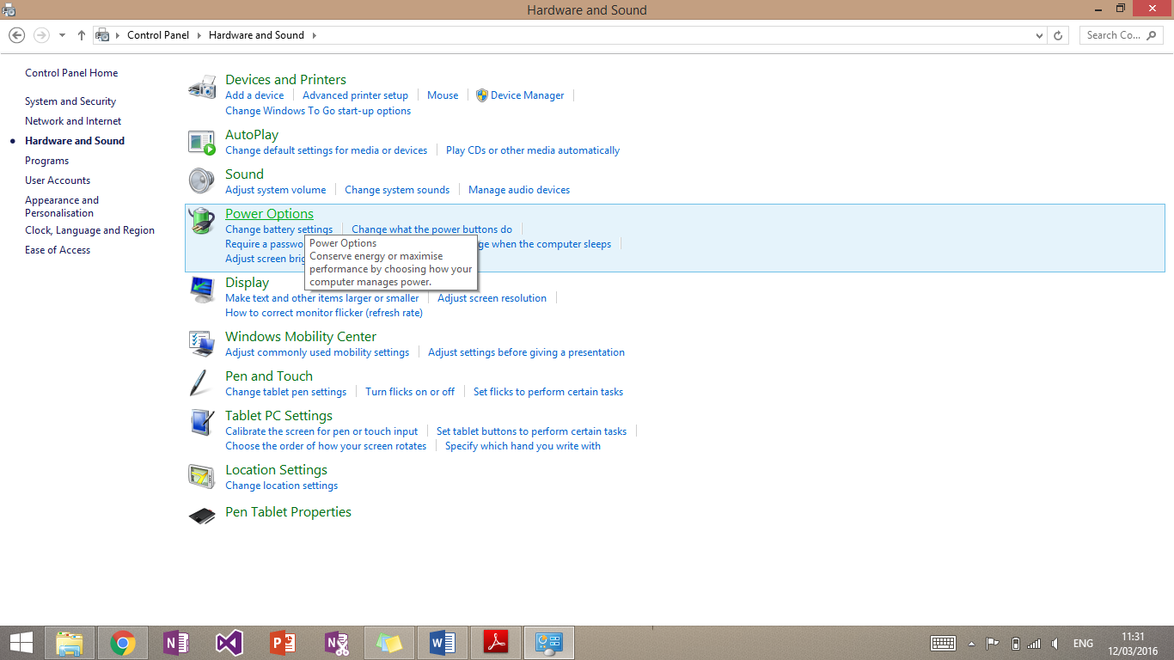

This then brought me to the Hardware and Sound page. I then clicked power options.

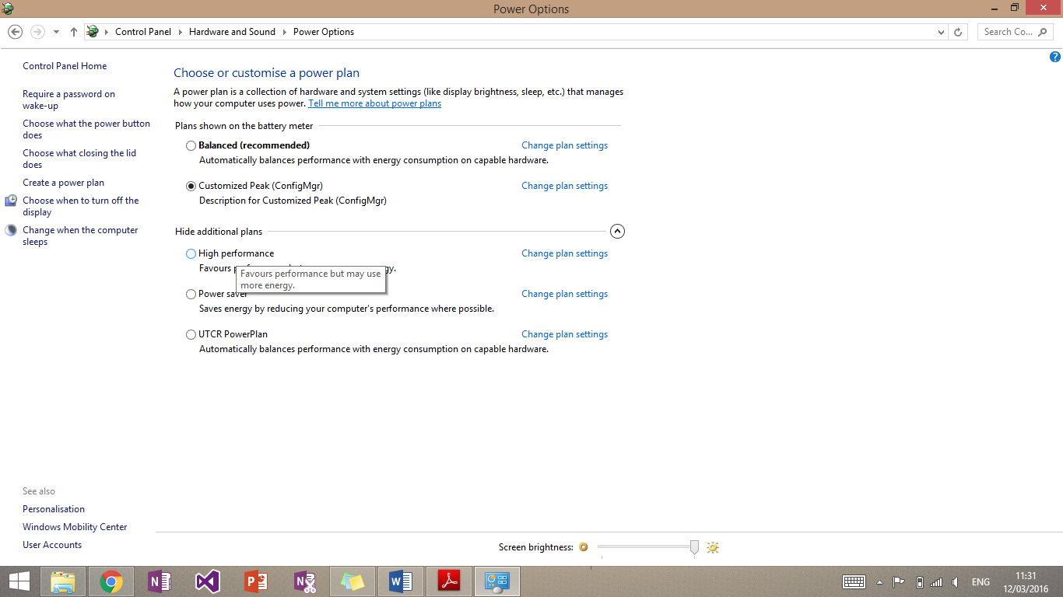

From here I could set up everything to do with power management. The section I wanted was called “Choose when to turn off the display”. This was located on the far left of the page.

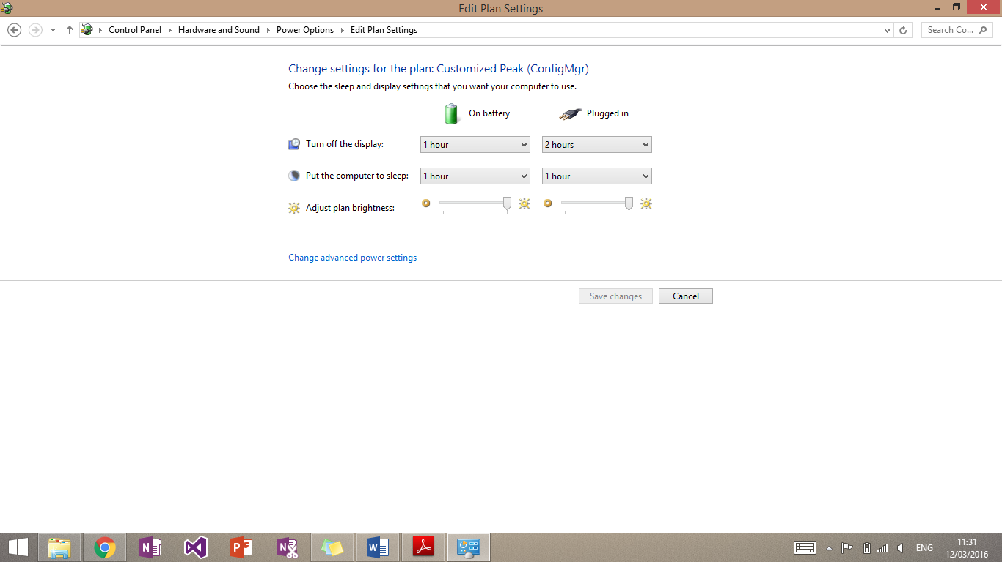

This then brought me to a page called “Edit Plan Settings”. From here I could specify what happens when the computer is plugged in or on battery.

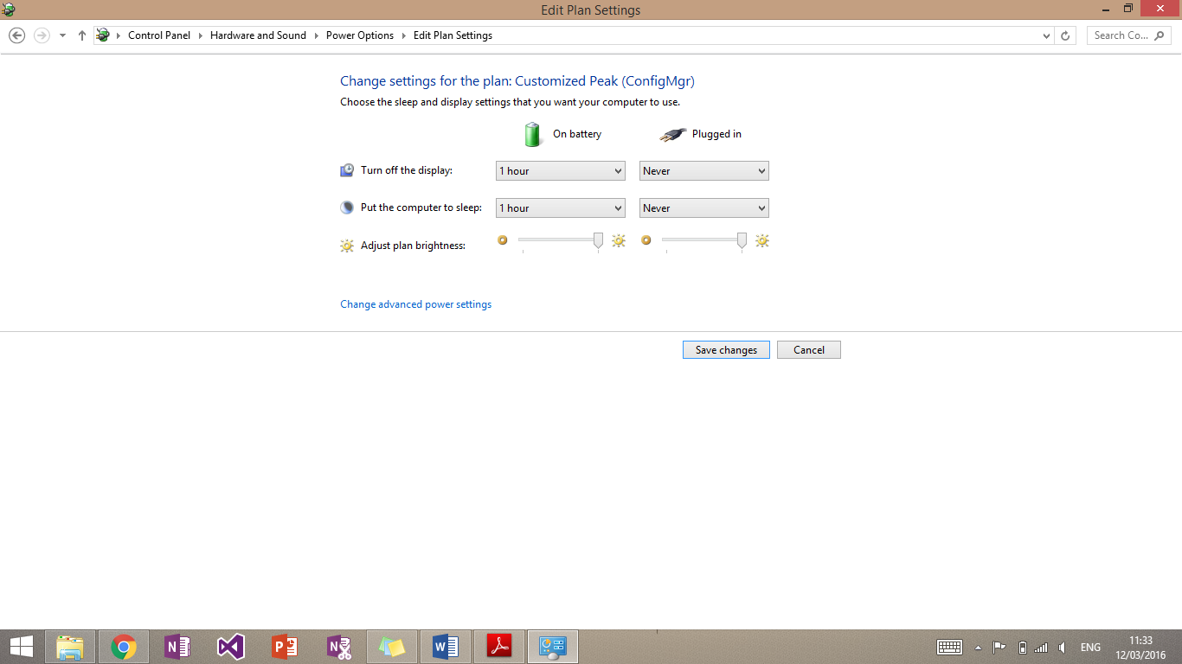

I set up the computer as shown above by using the drop down boxes. This set up would mean the computer would never turn off the display or go to sleep when it is charging, as depicted above. I then confirmed all, of this by pressing the ‘Save changes’ button.

## Screen resolution

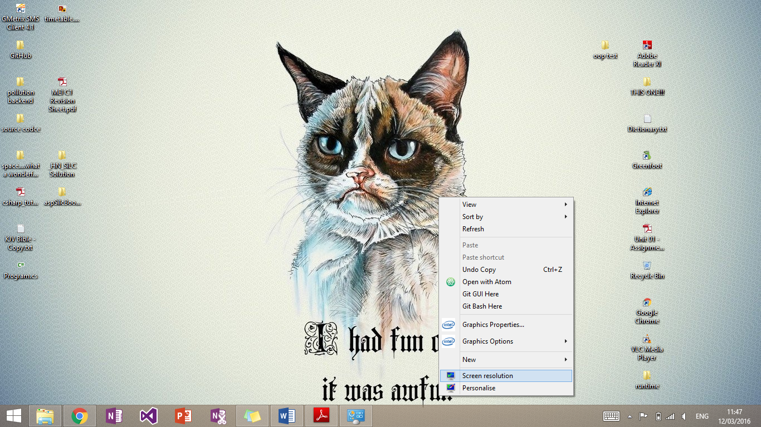I wanted to setup the resolution of the computer to be the native resolution of the display. This can be identified by the “**(Recommended)**” in the screen resolution page.

The screen resolution page can be found by going to the desktop and right clicking the background. Then select the ‘Screen resolution’ icon.

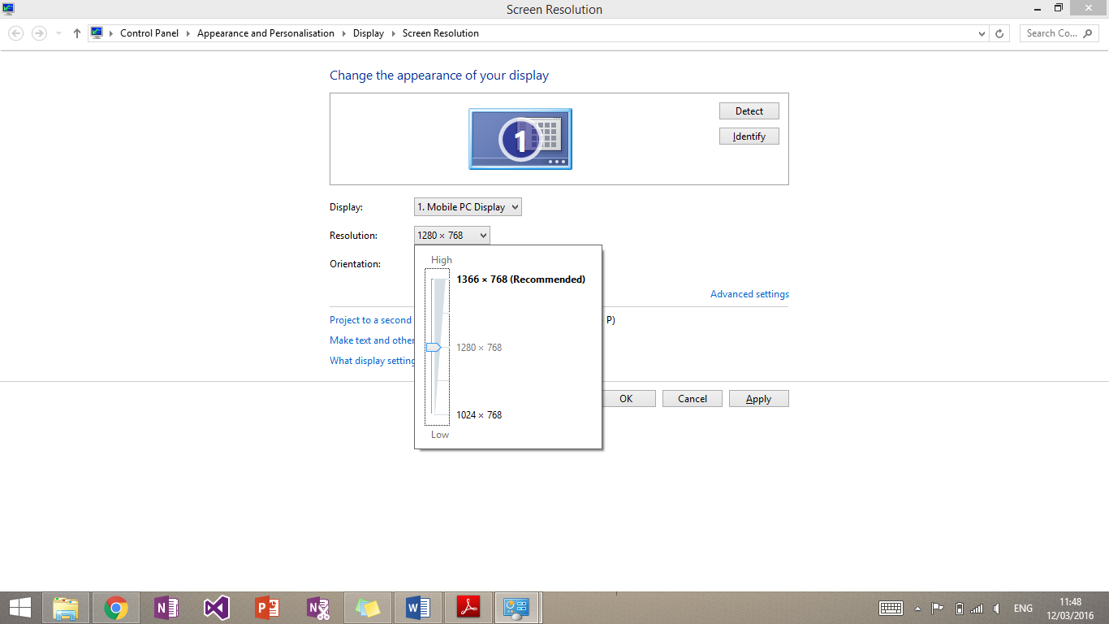

I then selected the resolution drop down box. This is how found it. Obviously it was no at the native resolution as detailed above.

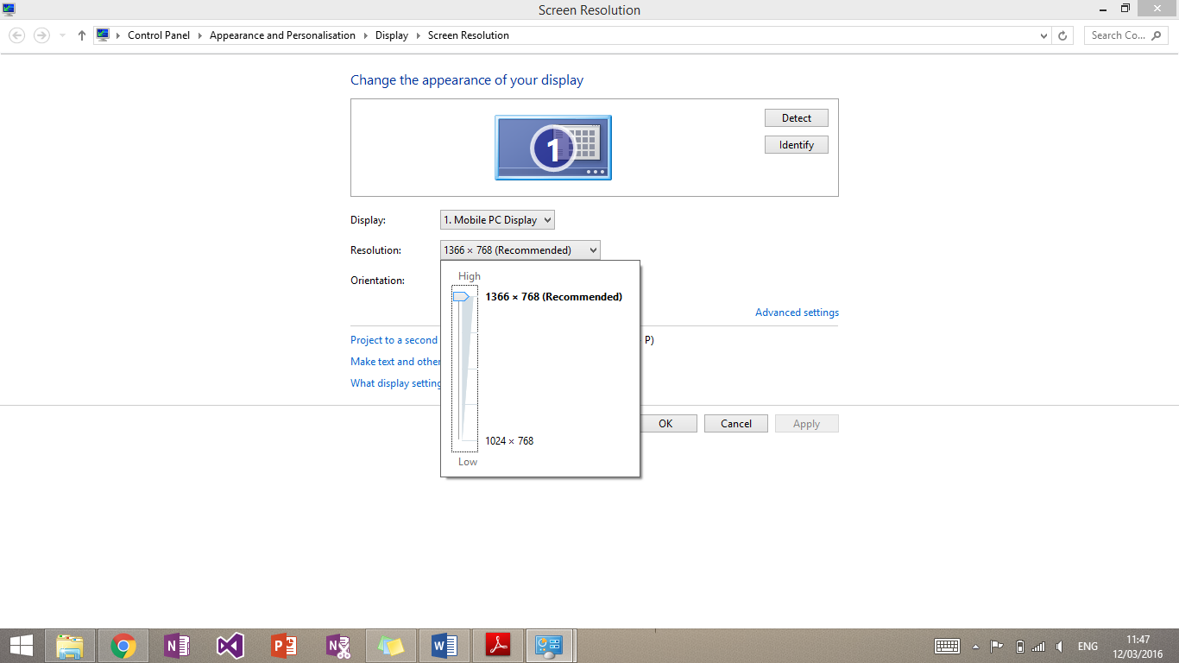

I then selected the native resolution and pressed ok to confirm it.

## Desktop theme

The user may want to change the background to the company logo or something personal to them. I will be showing the latter.

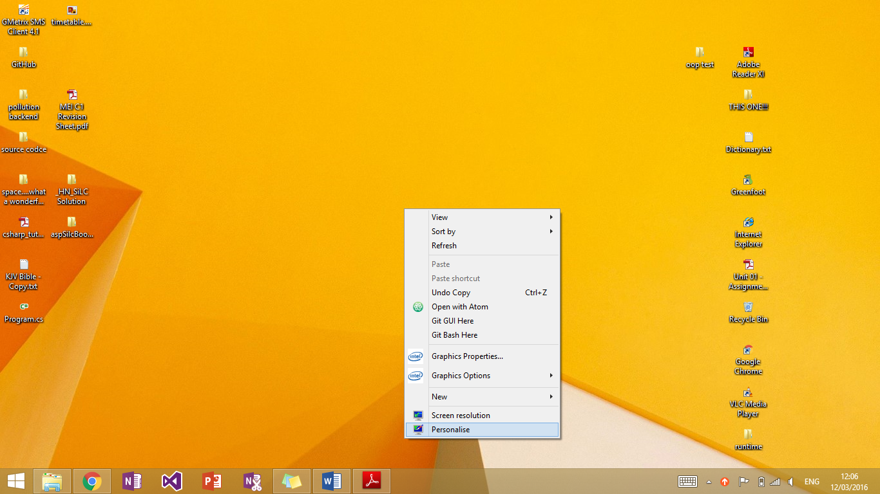

To get to the right page I right clicked the desktop and selected the ‘Personalise’ icon. 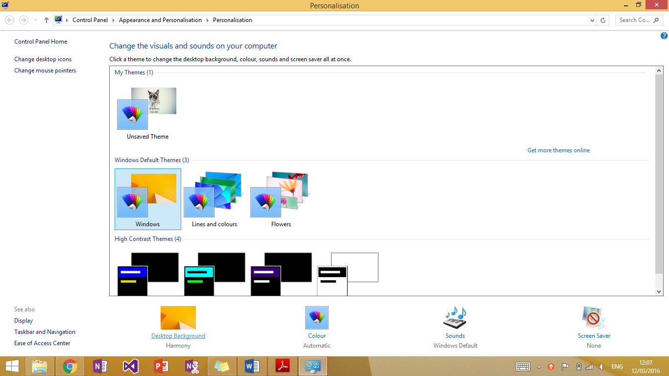 That then brought me to this page where I could choose premade themes. I selected the ‘Desktop Background’ link shown at the bottom of the page.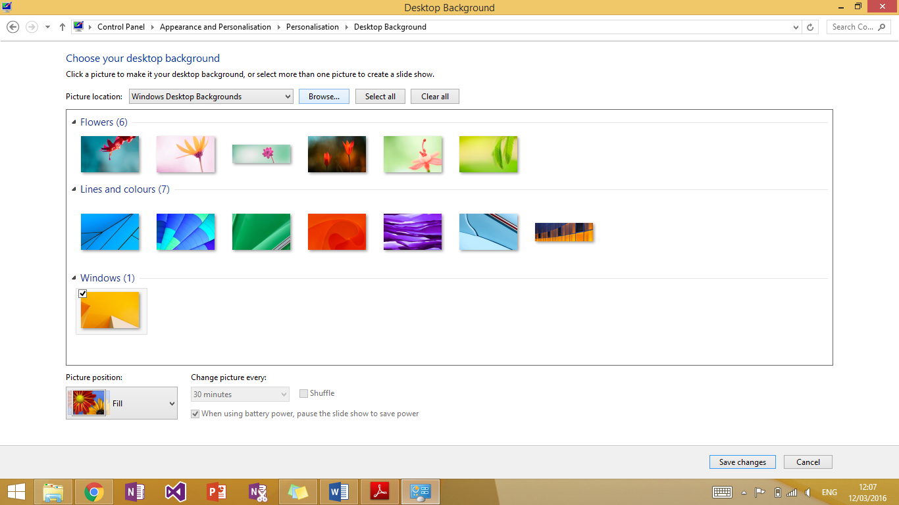

I then selected browse at the top of the page to navigate to the chosen file. 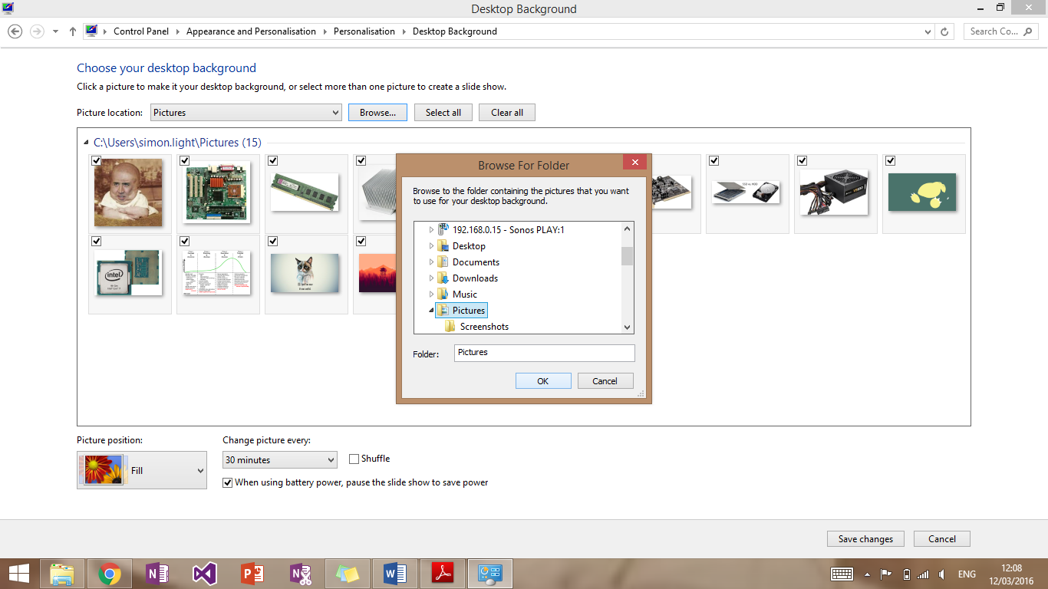

That then displayed this window. Once I had navigated to the preferred image (mine was stored in Pictures) I pressed ‘OK’.

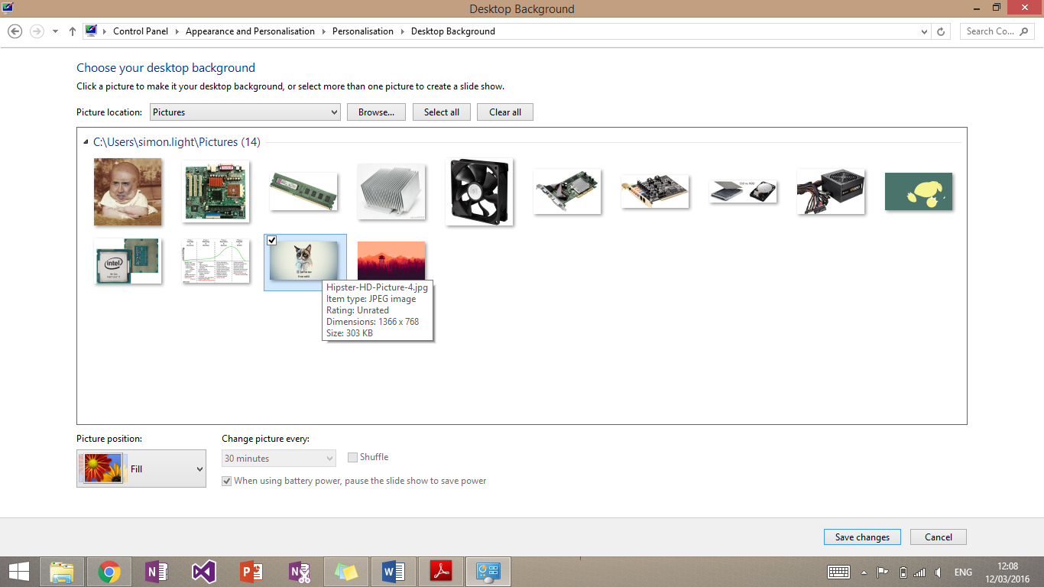

This then showed all images in that folder for me to choose from. Once I had done this I confirmed my decision with the ‘Save Changes’ button.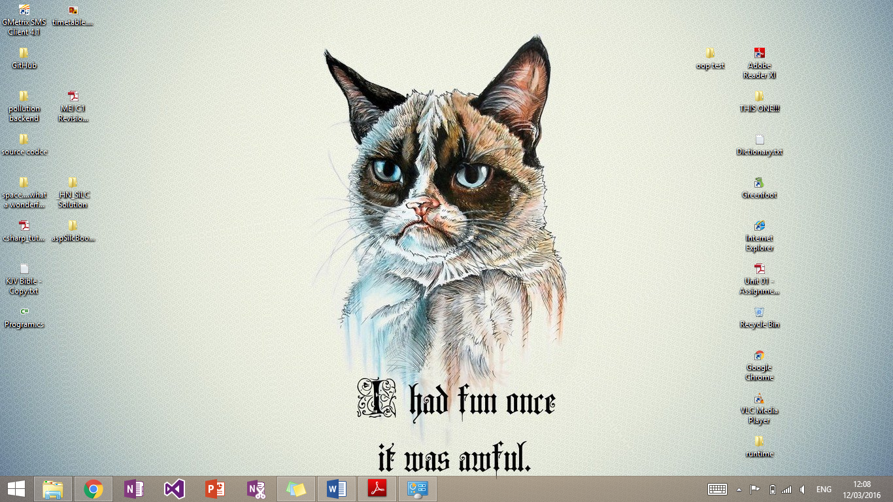

This then made my chosen image the background of the desktop as shown above.

## Font size

A user may want to make the text on their computer larger if they are visually impaired.

To start I opened control panel and typed in the search bar at the top right “font”.

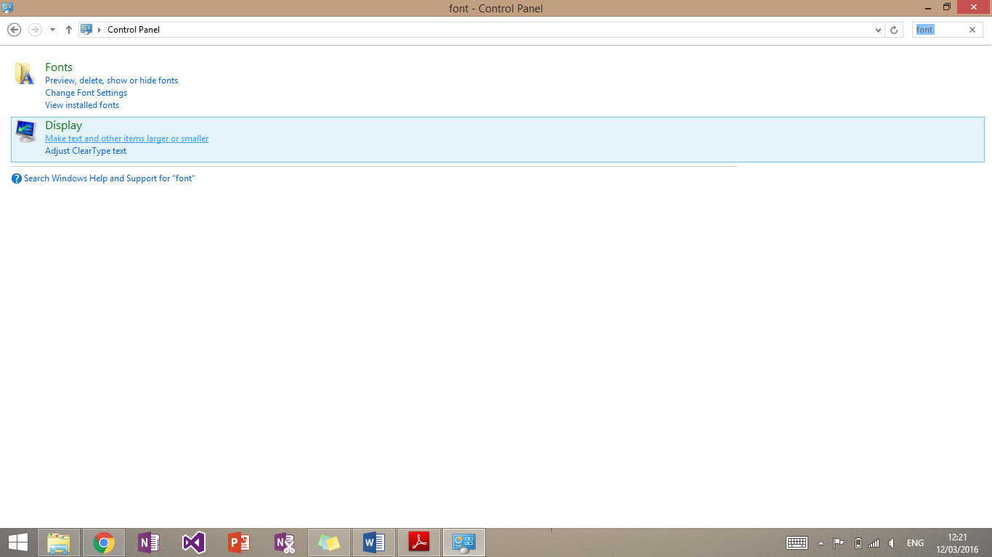

This will bring up this window. I then clicked “Make text and other items larger or smaller” under the “display” tab. 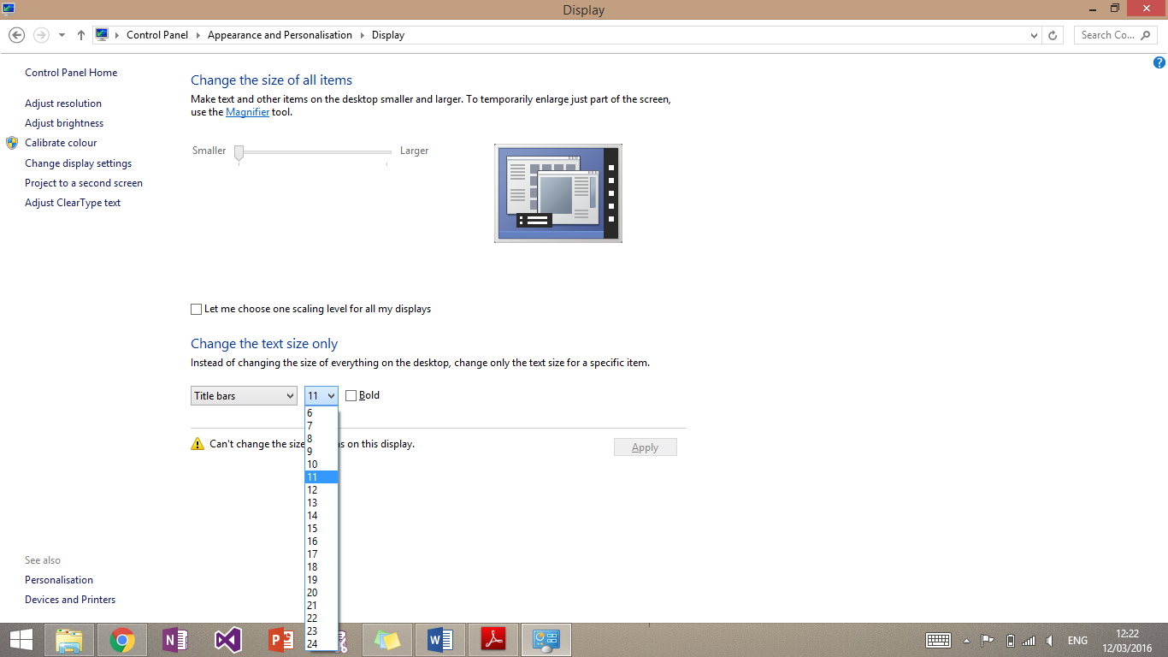

It will bring up this page. Then press the drop down box to change the font size. The default size is 11.

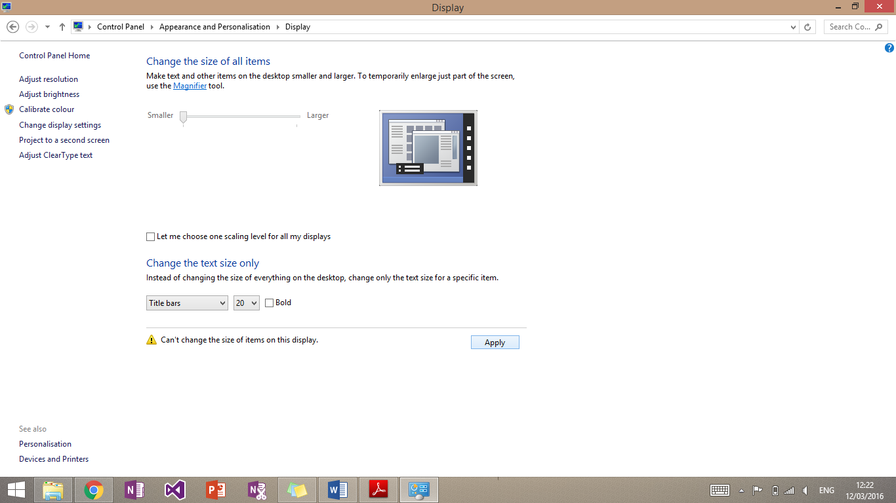

You can then change the size as required and then press ‘Apply’ to confirm this.

## Default language

A user’s native language may not be English. This means that they may need to change the language on the computer for ease of use.

I started off by opening control panel and searching for language.

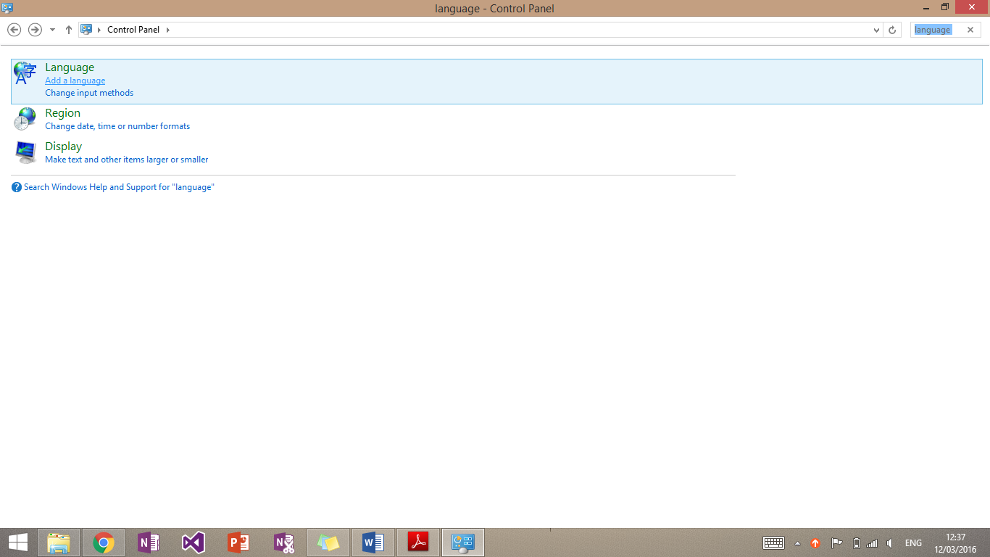

I then clicked “Add a language” under the ‘Langauge’ tab.

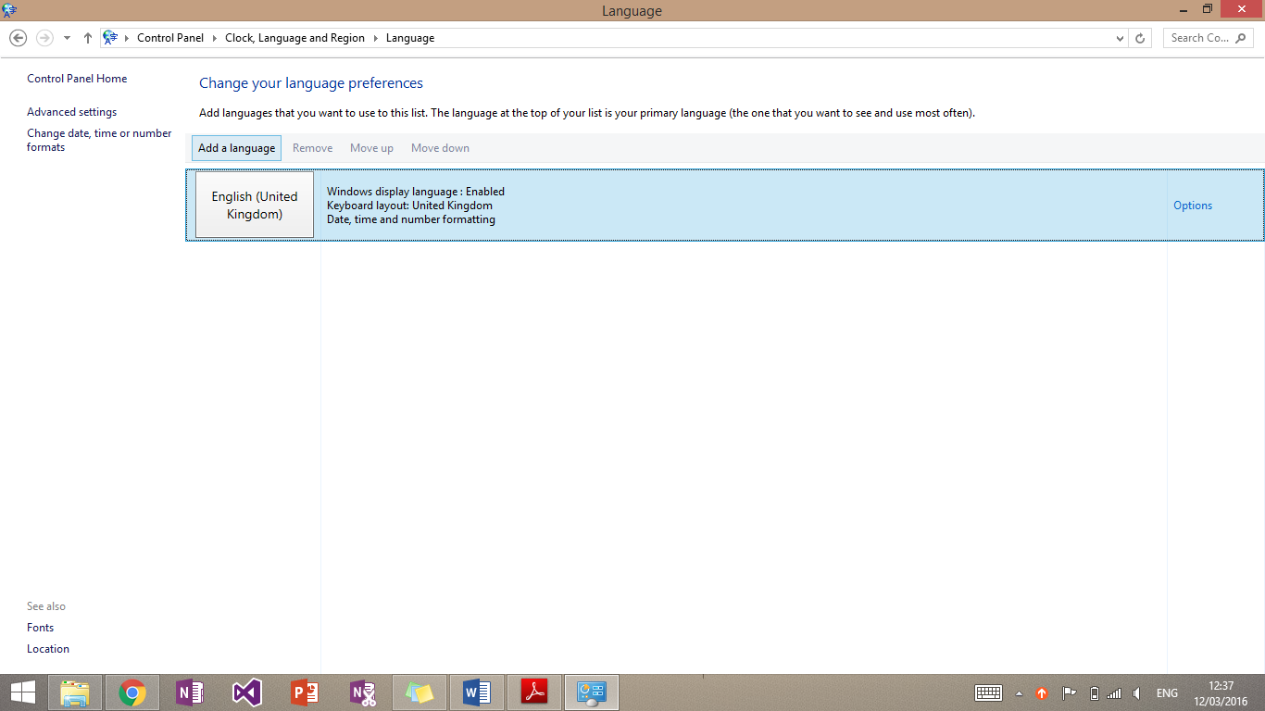

I then selected add a language.

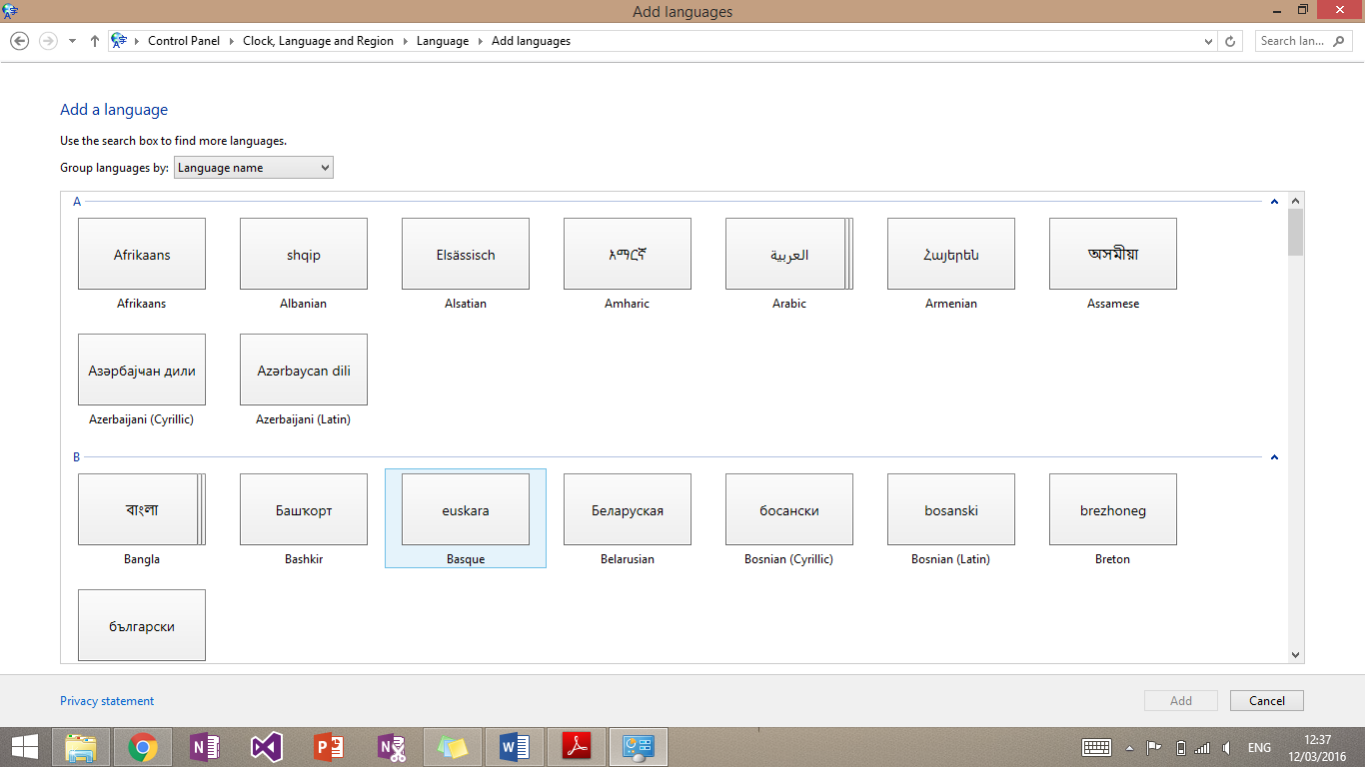

I would then select the language required and press add. It will then install the language pack and may require the computer to restart.



Once this is done return to this point, click the language required and then press “Move up” as shown above. I have not done this on this computer as another language is not required.

# P7 – Test a configured computer

Once I had configured the computer I had to test whether it was configured correctly. The test should check whether the system is working correctly, all hardware is correct and present and all applications are working correctly.

Below is a test plan of how I will make sure of this.

|  |  |  |  |
| --- | --- | --- | --- |
| Testing | Condition/Action | Expected Outcome | Actual Outcome |
| Time and Date | Check time and date compared to actual time and date | Both are the same | Both are the same |
| Opening Software | Open OneNote | OneNote Launches | OneNote Launches |
| Start Button | Log out | Logs out | Logs out |

Below is evidence of these tests:

## Time and date

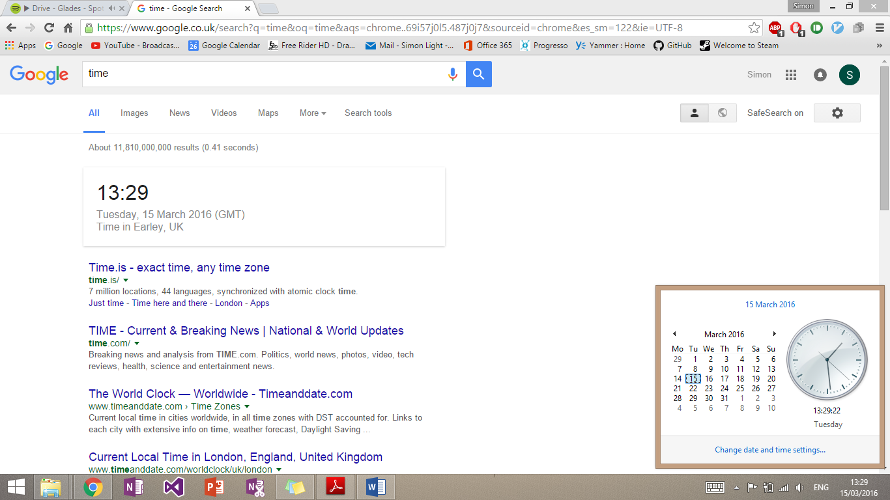

As you can see above I compared the time on the computer with the time displayed on Google. This is a secondary reliable resource to check against. The times were the same.

## Opening software

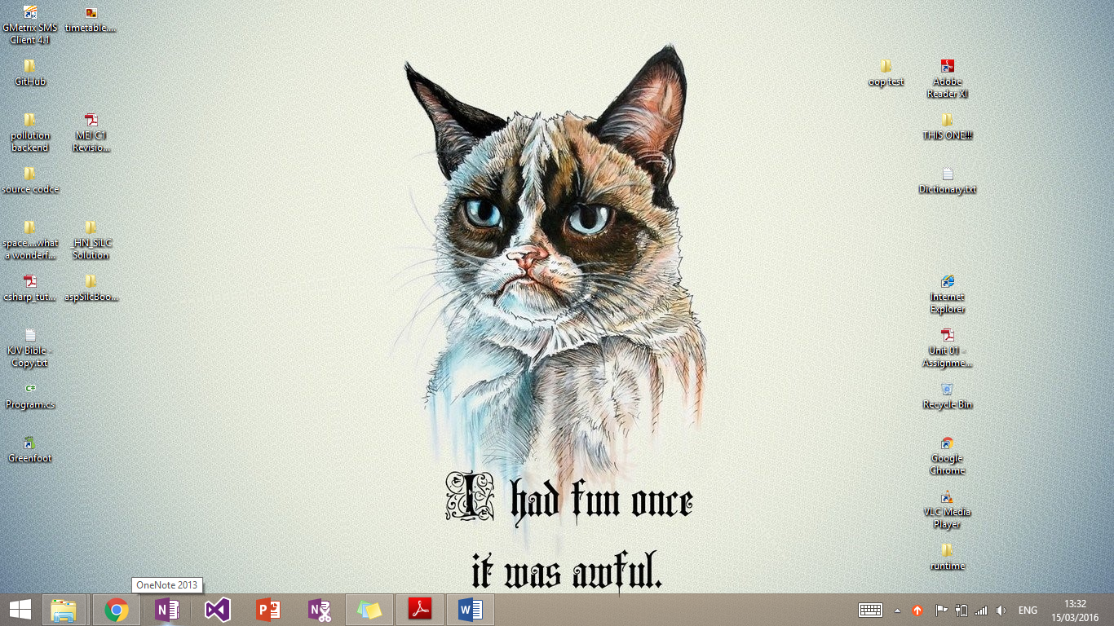

I clicked on the OneNote on the task bar.

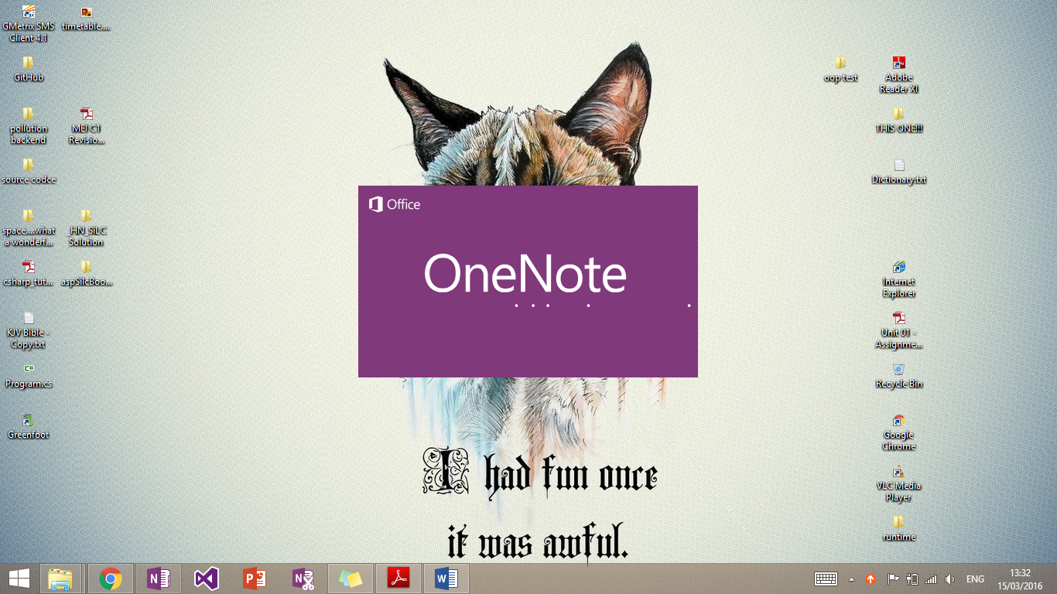

It then started to open OneNote.

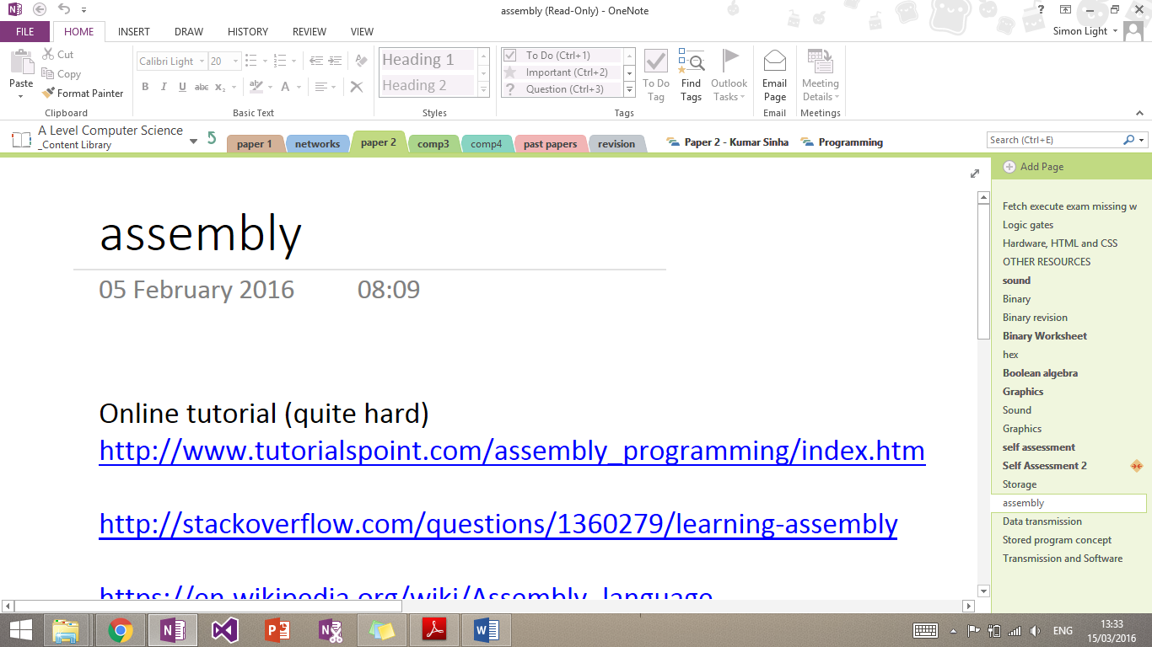

It opened OneNote successfully and passed the test.

## Start Button

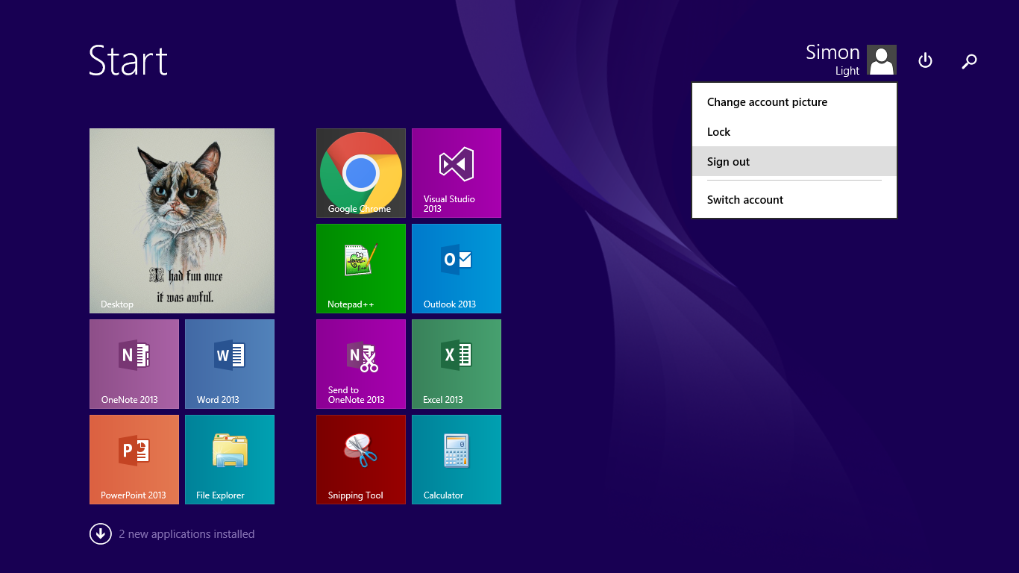

I pressed the sign out button and the computer successfully signed out. I could not give evidence but the test was passed.

# P8 – Routine maintenance

## Restocking printer

### Paper

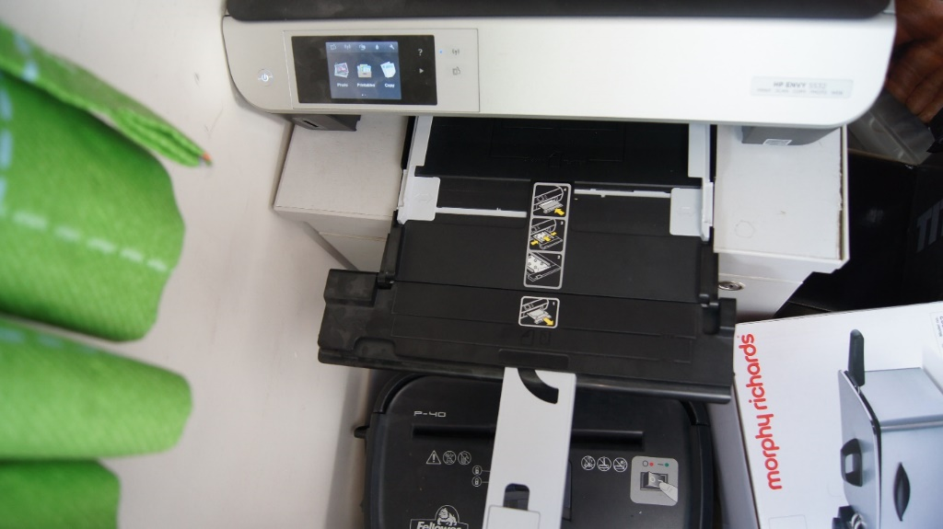This is the printer without any paper in it.

I firstly pulled out the paper tray.

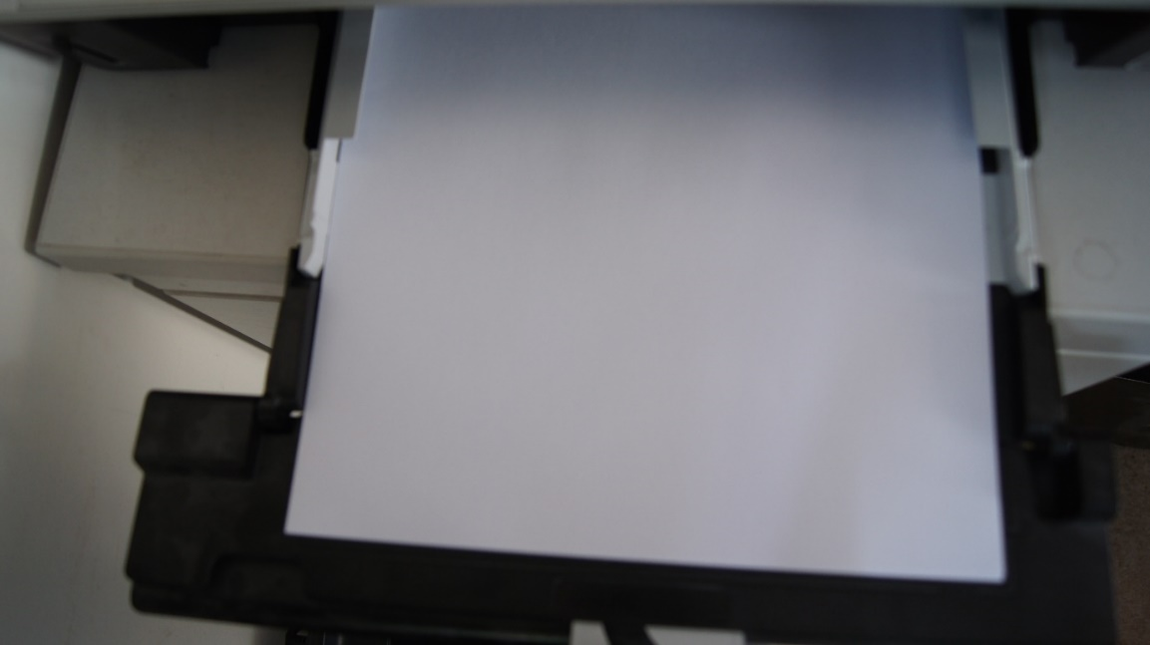I then loaded the paper into the tray.

And pushed the allignment pins until they were touching the paper

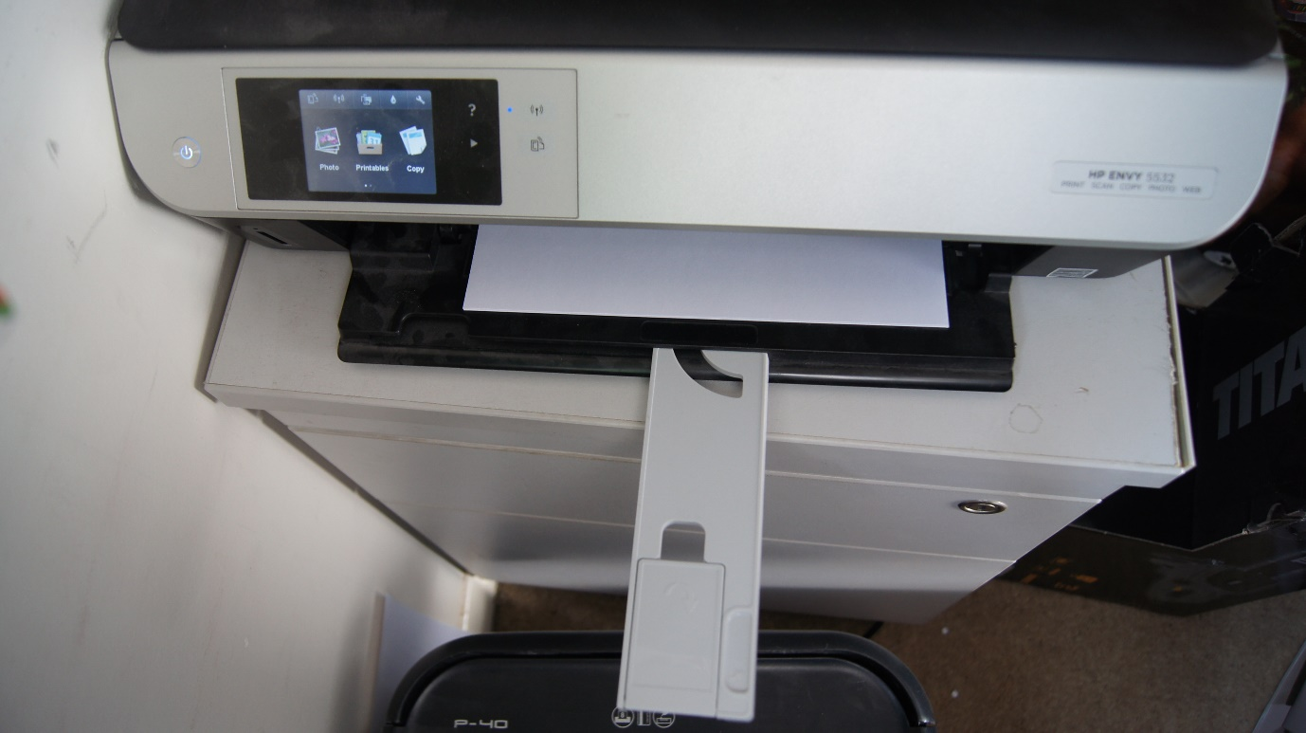

I then slid the tray back in.

### Ink

I started off by lifting the lid and locating the ink trays (far right hand side).

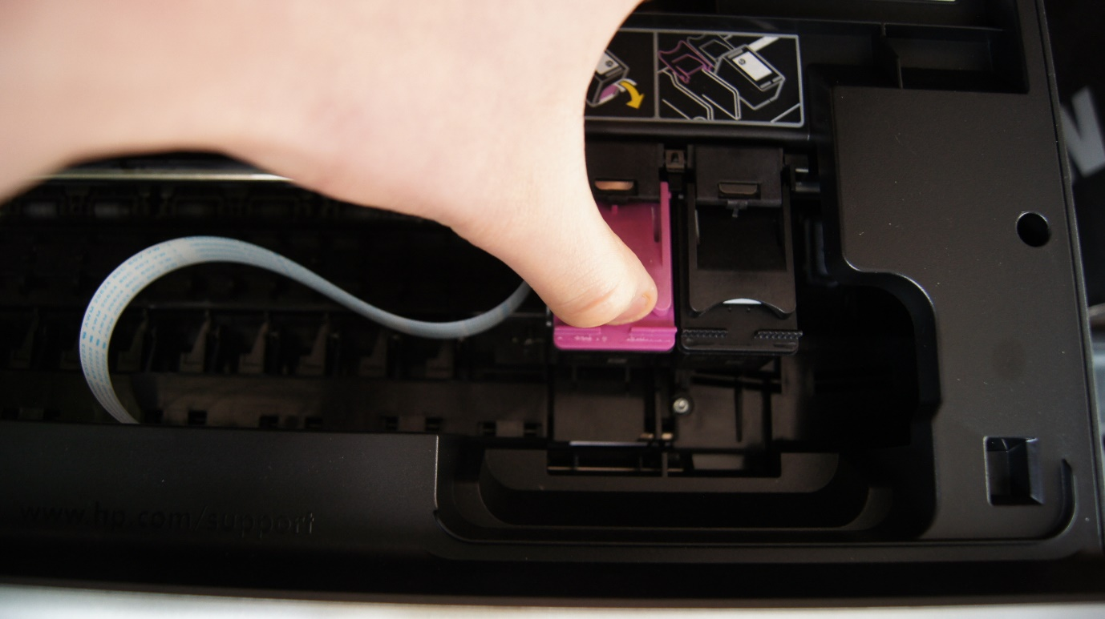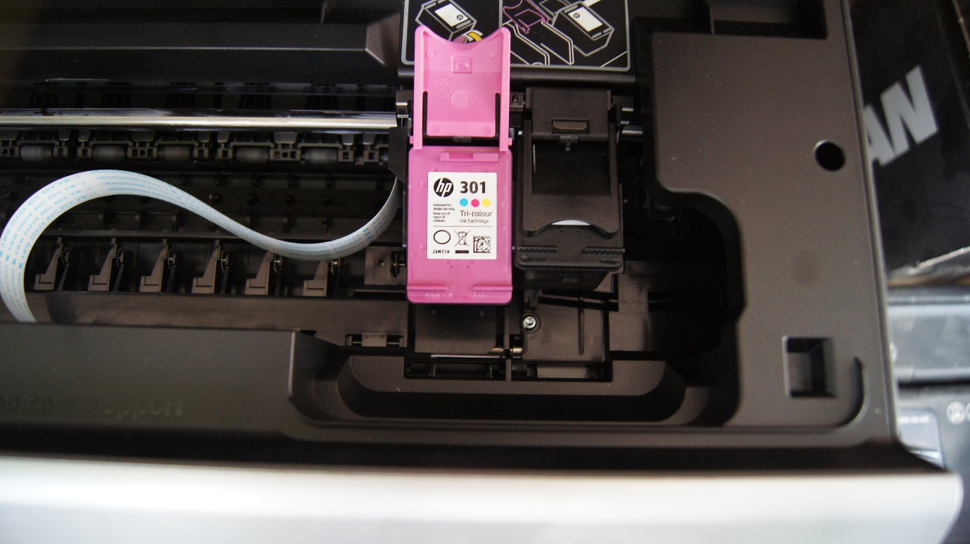I then lifted the release catch

And removed the cartridge

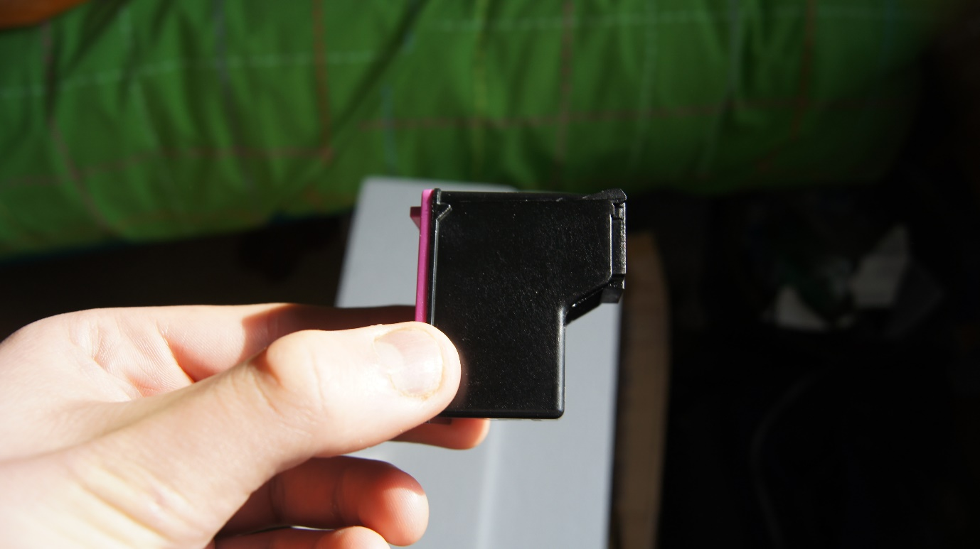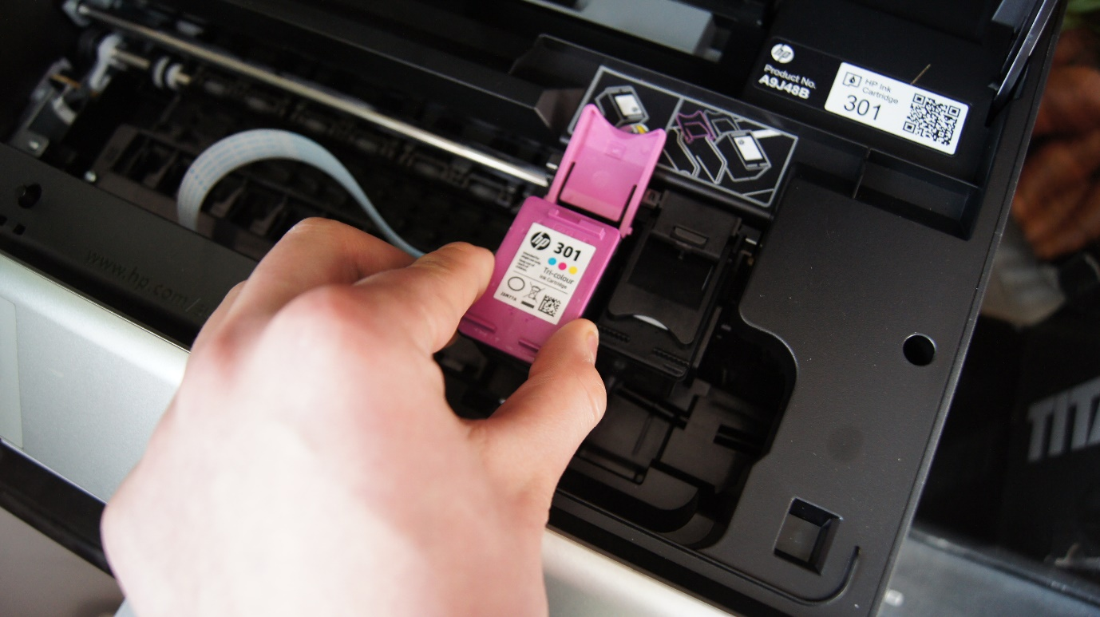I then found a replacement cartridge and checked it for compatibility.

I then placed the cartridge in the slot

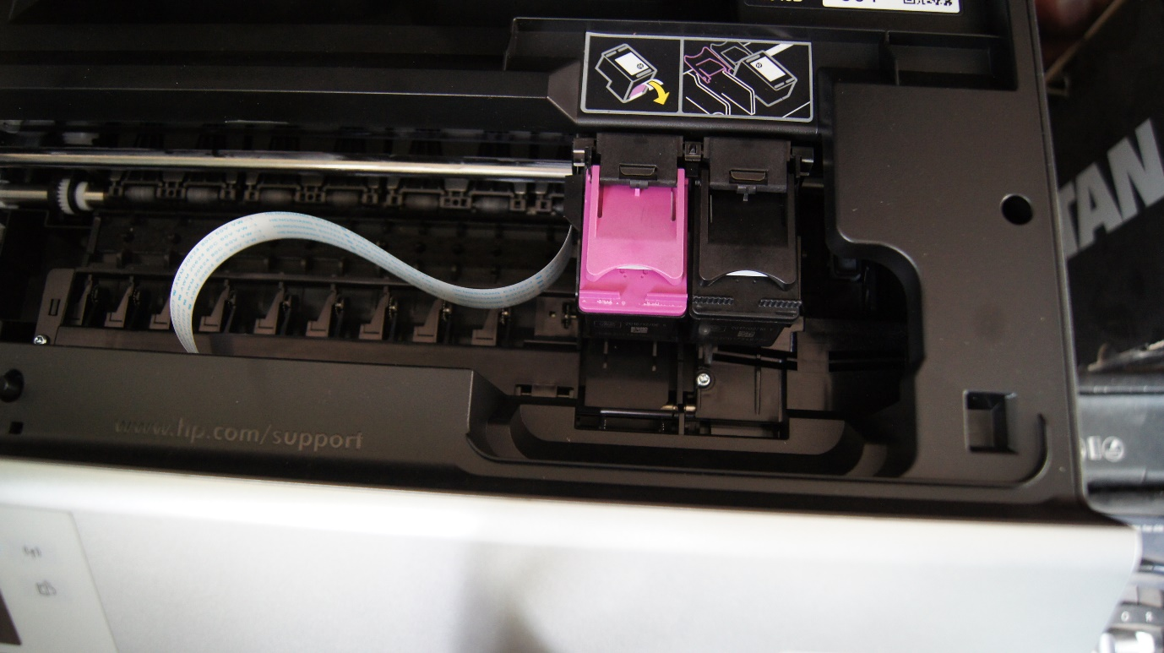

And closed the arm and then the lid

## Defragging disk

Disks need to be defragged to reduce the access time to files. This time is inreased when more files are added to the disk.

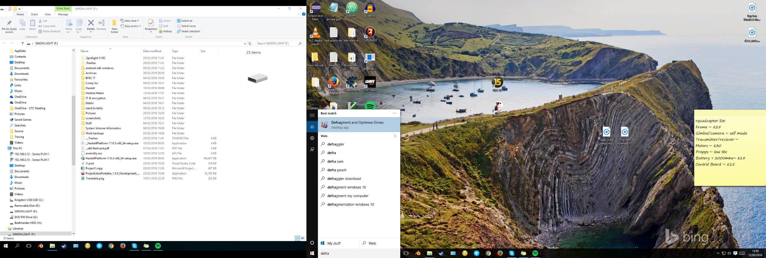

The first thing I did was search for defrag in the search bar. This then brought up “Optimise Drives”.

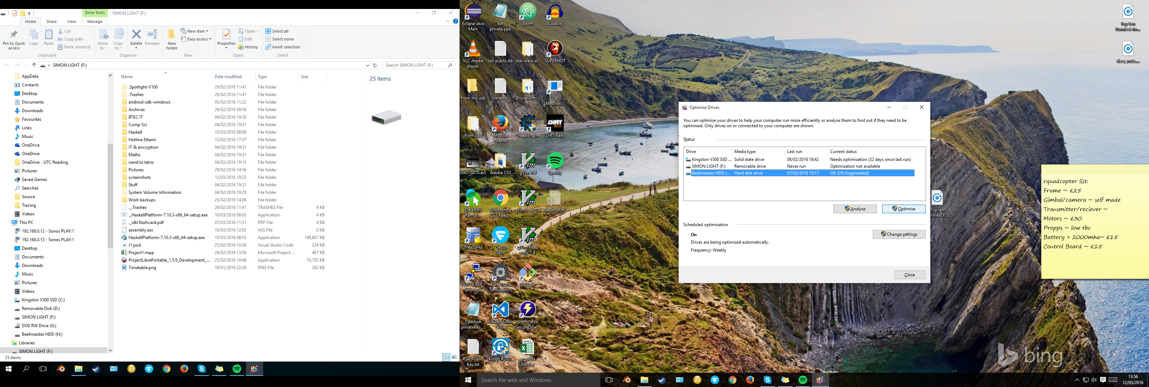

Once there I selected the drive to be defragged and clicked optimised.

It will then go through the steps to defrag the drive while you carry on using the computer.

# M3 – Evaluate performance of a computer

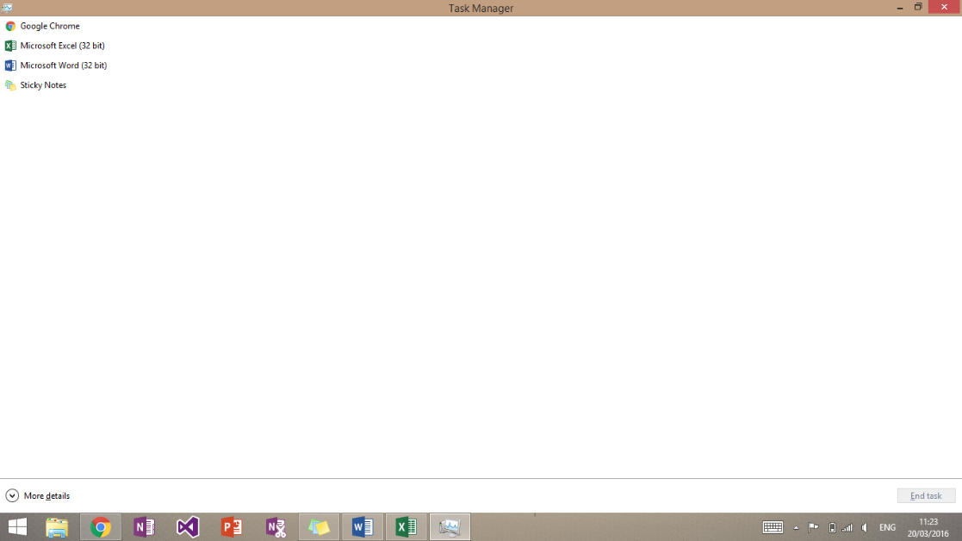To check the performance of this computer I opened up task manager by simultaneously pressing CRTL, SHIFT and ESC.

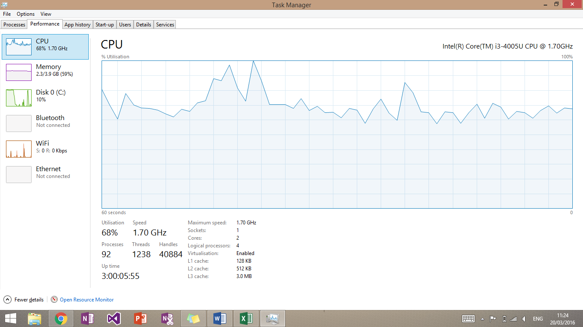This then showed me this screen. This, along with the taskbar, shows what applications I had open. This shows I had Word, Excel, sticky notes and google chrome open. These are applications that typically would be used at the same time in a workplace.

I then pressed more details at the bottom of the page, then the performance tab at the top. This then shows the usage of the CPU over time. In this case, due to the fact that the CPU hits 100% just by viewing task manager with the applications open, I would consider upgrading this CPU. Failure to do so may mean that when an application is doing heavy tasks (i.e. saving) then it may result in this computer crashing. This reduces productivity of the workforce and inevitably loses the company money.

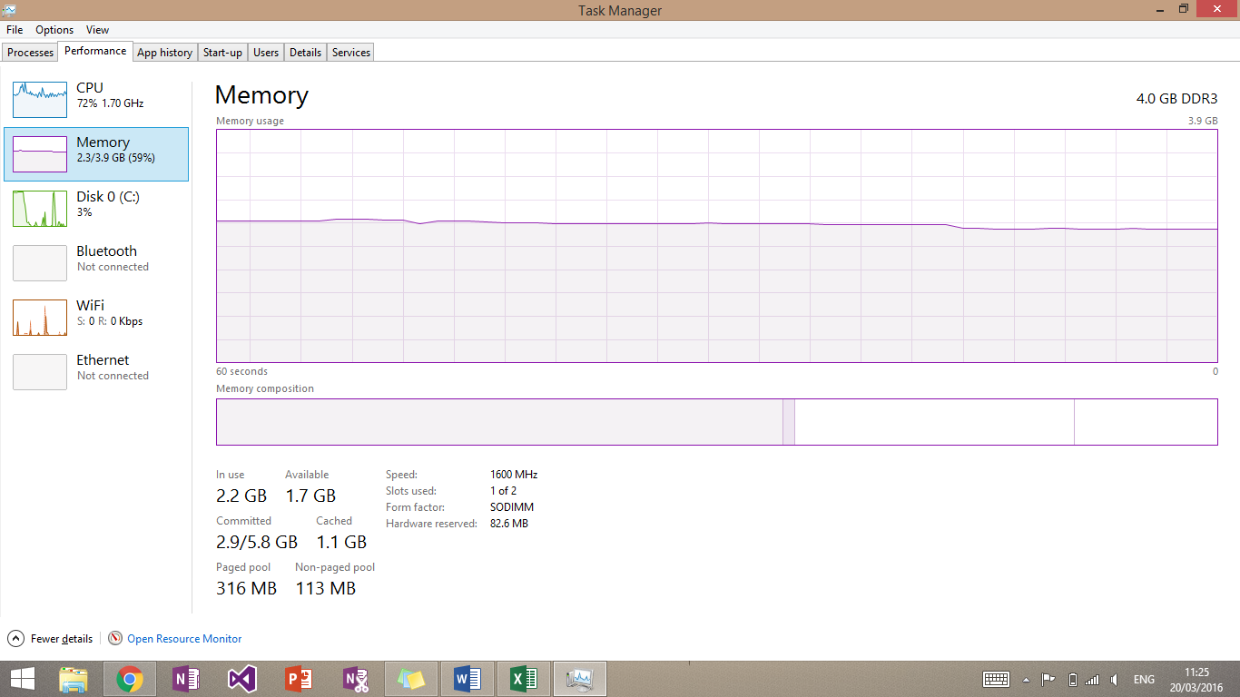The memory is sitting solidly around 60%. This means that there is room for when applications are completing tasks and when more applications are open. I would not recommend upgrading the RAM as its performance is good.

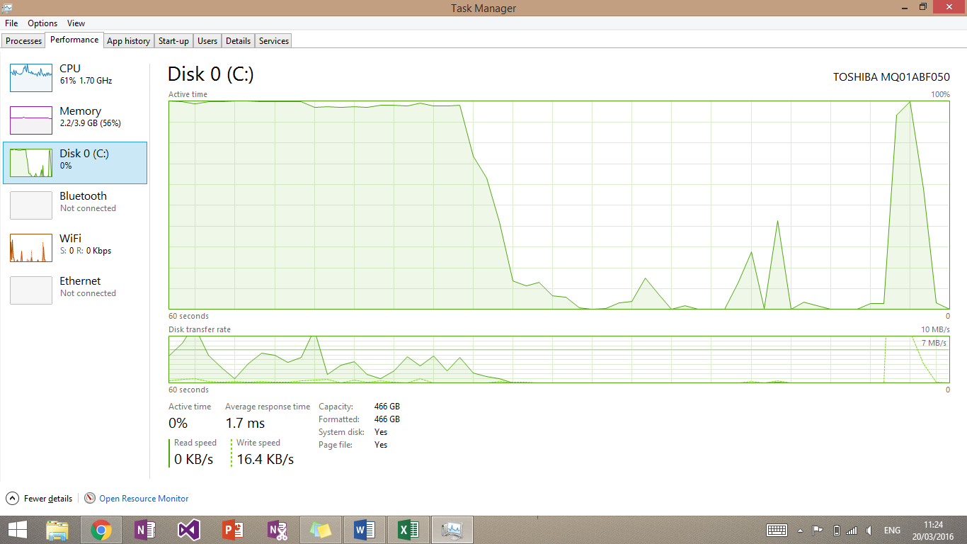

The disk is seen to have spikes on this graph. This is very normal on the disk as it will be opening or writing to files and then doing very little. The fact that the disk is hitting 100% is cause for concern. When this happens a user may find that file editing may become slow or even non-existent. This may result in loss of work again costing the company money.

I would change the boot drive to have and SSD. This separates the boot and file drives so that when they are both being needed they don’t max out. It also means that tasks will happen much more quickly and any effects like the ones detailed above will only happen for a short period of time.

# D2 – Explain and justify improvements to a computer

## Hardware Improvements

### Increase Hard Drive Capacity

The computer had a 60GB SSD along with a 1TB driv3e for applications. They also had subscription to Office 365 which gave them an extra 1TB of storage, perfect for storing files. If the operating system they are using is very large and they need a lot of fast to open applications, they may need to upgrade their SSD to a 120GB version (this is included in the original budget).

If a staff member uses a lot of large applications or large files (such as a database manager) then it may be necessary to upgrade their hard disk space. This can be done one of two ways: adding another 1TB (or other) hard disk to their current computer or, upgrade their office 365 account to include extra OneDrive space. If the staff member has filled up their current system with files, then I would suggest that the OneDrive option is taken forwards. Otherwise I would suggest upgrading their actual computer.

### Increase RAM Capacity

It may be seen by the users of the computers that RAM usage is very high. This will mainly be identified by a very slow computer when using multiple applications. This can then be assured by looking at the RAM usage on the machine to confirm this is the case. It is very likely that the network administrators will have access to this information and so will be able to advise users accordingly.

The computer comes with 4GB of high speed RAM which will be enough for all 'office style' work. This means having a few applications open or one large one. Any user that completes more than this type of work will need a RAM upgrade. This can be just another stick of RAM increasing the total to 8GB. This should be enough for almost all types of work. A few users who do a lot of work with very large applications and files (again like a database manager) and then they will need a larger upgrade. I would suggest buying an 2X8GB sticks to give the best performance without going over and above.

## Software Improvements

### Updating Software

The computer systems can be greatly improved by upgrading and updating software. If software is left to sit and not upgrade, it can often do more harm than good. One example of this is when applications create an alert every time the users computer starts. When lots of applications do this at the same time it can create a very slow boot time.

Some software may become a threat to the computer as well as the company if left not updated. This is software such as such as security, virus protection and even file transfer software. If a users anti virus software is left not updated then the computer is vulnerable to attacks. These attacks can create viruses on their computers that will then try to stem to the entire network. This will then cost the company a lot of time and money to remove from the network.

### Upgrading/Updating Operating System (OS)

An operating system is the largest and most important piece of software on a computer but it is also the most neglected. It is a good idea to ensure that all users have their machines auto update. A slow operating system can make things seem a little strange on a computer. These changes can range from incorrect system usage information to not supporting applications that wee previously fine.

Upgrading an Operating System should be done with caution. Companies will often release an OS in unstable form as a large beta test. They will then release more and more stable versions throughout the weeks after the initial release. This is not the best thing for a work computer. Firstly, there are a lot of bugs in the day one releases of OS's and this will slow you down a lot. Secondly, having to stop everything you are doing every couple of hours to update to the most recent version is very tedious and will beak up your work flow.

# Appendix

http://www.bbc.co.uk/schools/gcsebitesize/ict/legal/2copyrightrev1.shtml